NEW ENGLAND AND THE WORLD
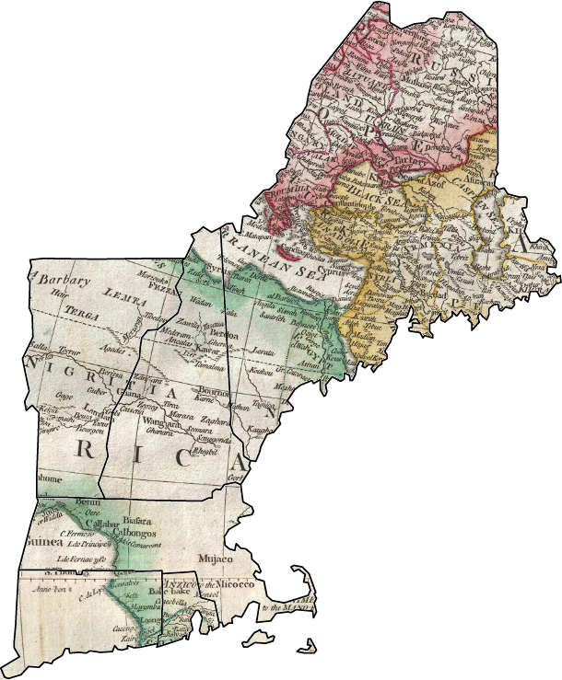

American and New England Studies Program at Boston University
Graduate Student Association Conference
October 24 & 25, 2014

Plenary Speaker:
Dolores Hayden
“Domestic Revolution:
A New England Scandal from 1868”

Professor of Architecture, Urbanism and American Studies, Yale University

Elie Wiesel Center for Judaic Studies Registration Fee:
146 Bay State road Panelist $10
Boston, MA BU Students $15
Visitors $20

October 24, Friday at 3pm
October 25, Saturday at 9am

Sponsored by
Boston university’s Center for the Humanities
And the Graduate Student ORganization

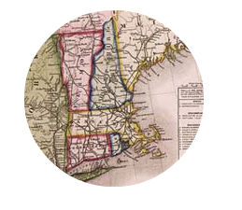
Friday, October 24

3:00-3:30 Registration/Coffee

3:30-4:15 Plenary Speaker:
Dolores Hayden, “Domestic Revolution: A New England Scandal from 1868” Professor of Architecture, Urbanism and American Studies, Yale University

4:30-6:00 People in the City
Chair: William Moore

Naomi Slipp, Art History, Boston University: “The Specter of Smallpox in Ante-bellum Boston: Building a Medical Reputation through Visual Culture”
Chris Tucker, Clark University: "Turnpikes and Tenements: Housing Discrimination in Three New England Cities"
Ian Stevenson, American and New England Studies, Boston University: “The American Underground Frontier: Boston Subway Construction and Photography, 1894-1897”
Chelsea Gibson, History, SUNY Binghamton: “Suffrage and Revolution: Boston’s Women and the Movement for a Free Russia”

6:00-7:00 Reception

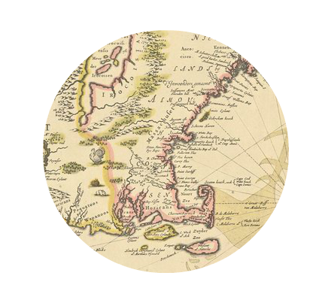
Saturday, October 25

9:00-9:30 Registration/Coffee

9:45-11:00 Shaping Colonial Identities
Chair: Joseph Rezek

Amy Noel Ellison, History, Boston University: "Errand Through the Wilderness: New Englanders and the Invasion of Canada, 1775-1776"
Dylan LeBlanc, History, University of Notre Dame: "'To Account Our Selves Knitt Together': John Winthrop, Performative Text, and Communal Self-Fashioning in the Massachusetts Bay Company, 1629-1630"
Brett Culbert, American Studies, Harvard University: “Copley Seams in Watson and the Shark: The Figural Stitching of Subject, Artist, and Genre”

11:15-12:30 Rethinking the New England Mind
Chair: Hunt Howell

Jamie Devol, American and New England Studies, Boston University: “The Romantic-Pragmatist: Louis H. Sullivan and The Autobiography of an Idea Reconsidered”
Tim Sommer, English and American Literature, Universität Heidelberg: “Negotiating Cultural Authority: New England Intellectuals and the Challenge of the English Literary Tradition”
Christopher Allison, American Studies, Harvard University: “The Material Mind: George Whitfield’s Corpse in New England and English Phrenology, 1770-1860”

12:30-1:30 Lunch with Alt-Academy Panel
Chair: George Born

Edith A. Tonelli, Ph.D., Director, Cape Cod Museum of Art
Joshua Cracraft, Ph.D., Program Director, Primary Source
Lauren Proll, Ph.D., Instructor, Boston University Academy

1:45-3:15 Community, Conflict, and Cannibalism
Chair: Marilyn Halter

George Schwartz, American and New England Studies, Boston University: “Collecting and Arranging...a History of the Globe”: The Salem East India Marine Society Museum and the Formation of American Identity”
Nicole Topich, Archivist, Harvard University: “Personal Replevin: Slavery in Massachusetts and the Kidnappings of People of Color”
Carla Cevasco, American Studies, Harvard University: "This is My Body: Communion and Cannibalism in Colonial New England"
Rachael Abbiss, History, University of Chester: "Imperial Ties: British Isles and New England, 1686-1689"

Closing Reception

