Meet the

new eboard!

President- I am Marie Hoff and I am the president of the team this year. I am a sophomore studying elementary and special education. I love to read, eat, dance, and spend time with my wonderful family and friends. I am pleased to be on the executive board this year. I hope that we continue to be a close-knit community. I would also like us to perform even better at competitions, especially Nationals. Go BU!

Treasurer- Hi, my name is Leah Daniels and this is my first year as treasurer of BU Synchronized Swimming. I am a sophomore in the School of Education studying elementary education with a concentration in foreign language education (love french!). This is my second year doing synchro, although I swam and played volleyball in high school. I'm loving everything so far and will be swimming either a trio or a duet for the first time in competition this year!

Secretary- Hi! My name is Emily Kammerer, and this year is my first year as secretary for BU Synchro. I am a sophomore studying Spanish Education, and I am also a mentor for Generation Citizen, teaching a civics class in a middle school. This is also my 2nd year on BU Synchro, joining last year with no swim experience whatsoever. Thanks to our dedicated coaches, I am now swimming against varsity collegiate and Olympic swimmers! I am looking forward to swimming my first small routine, as well as editing our newsletter!

Dear Friends, Family and Alumni,

We have decided to send out a BU Synchro Newsletter to keep you updated on how our season is progressing. This year, we are off to a great start. We successfully recruited 5 new swimmers, who have jumped in to the world of Synchro and have all begun learning our team routine wonderfully. The brand new eboard has also been working hard to make this season the best yet, and we have added to our team of dedicated coaches with Amy Medico, a former BU Synchro swimmer as well.

This season’s accomplishments already include securing a dance studio space to stretch, workout, and landrill before practice, as well as the compiling the very first edition of our newsletter. We have all been working hard on learning our team routine, set to greek music. Come to our meets, and you just might notice that it sounds very familiar! It is a greek song, but was also translated into English and featured in the movie “Never on Sunday.”

We are very excited for this season, and are pleased to keep you updated with our achievements this coming year. Our first meet is December 4th, at Wheaton College, so be sure to look for our next newsletter to see how we did!

Sincerely,

Boston University Synchronized Swimming

*Edited by Emily Kammerer*

*Secretary 2011-2012*



Volume #1 issue #1

­

November 2011

­

FAMILY, FRIENDS AND ALUMNI NEWSLETTER

*Issue 1- November 2011*

Boston University synchronized swimming

**­**

What is it like being

on synchro for the first time?

2010-2011 Boston University Synchronized Swimming

Team -🡪

**Being on the Boston University Synchronized Swim Team is an exciting new experience. Trying to get into the right position, keeping afloat and keeping with the beat can be challenging when you are upside down struggling for breath! But the challenge is definitely worth it. The skills required for this sport are nothing like what was needed for varsity swimming and diving. It requires so much concentration of breath and flexibility! Synchronized swimming is very pretty and graceful and it’s fun to ‘dance’ to the music. The hard work pays off when you finally figure out how to do a figure or a sequence correctly. And let’s not forget about the small team dynamics. The people I have met and the friends I have made are amazing. The coaches are phenomenal and I still don’t understand how they coordinate together with all the changes in routines!  All in all, it’s a great workout, a fun sport and an amazing team! Contributed by Sahana Simha**

One aspect of Boston University’s synchronized swimming team that is not often mentioned to our friends and family is that we are specifically a club team (as opposed to a varsity team). This means that in addition to the athletic facet of the sport, the members of the team are also responsible for many decisions which at other schools are left to coaches and athletic administrators. The executive board of the team registers each swimmer for meets, arranges for travel and lodging during competition and our budget. As a team, we have three primary sources of income: fundraisers, donations, and appealing to Boston University’s Club Sports Council for supplemental funds. The Club Sports Council is a monthly meeting of representatives from each of the club sports teams and each team has an equal vote in allocating the shared money. In order to apply for funds, a team must make a presentation outlining their budget, costs, amount each teammate is charged for dues, and how much they fundraise as a team. However, as of the October meeting the council had not received their annual grant. While this is likely a delay in funding and not an outright budget cut, all teams were put on notice to up their funding and not plan to rely on university funds for essential expenses like competition entry fees. This news has caused us to look for more fundraising opportunities and have a greater appreciation for the donations we receive as a team. Contributed by Kat Monahan

Contributed by Kat Monahan

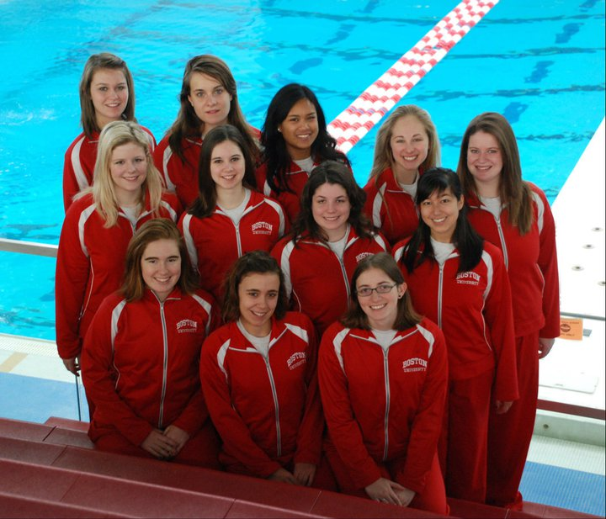

**what is a club sport?**



***I wouldn't say anything is impossible. I think that everything is possible as long as you put your mind to it and put the work and time into it.*** *Michael Phelps*

November 2011

­

Volume #1 issue #1

­

ALUMNI UPDATE:

Last year, four of our swimmers graduated, and each girl is thriving in her unique environment!



2011 alumni (from left) christina marmet ellen scott

rebecca sgouros

AND MISSING

jUSTINE sJOHOLM

And (Below) bu synchro coaches 2010-2011

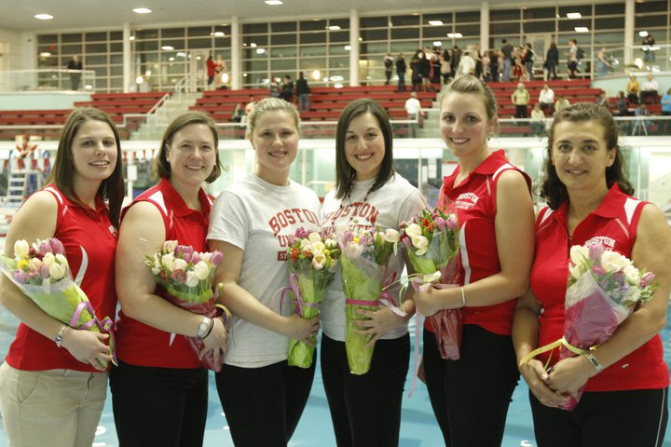

Christina Marmet is working for a marine conservation organization in the beautiful Seychelles Islands. Her work includes research dives (you can’t keep Christina out of the water!), community outreach through education, and learning about the various species of plants and animals of the surrounding waters. Here is a link to her blog: <http://christinaseychelles.blogspot.com/>

Ellen Scott is an associate account executive for a marketing firm and is enjoying apartment life in her hometown of Chicago. She misses her team and synchro very much, but no longer being the club’s treasurer has its benefits, too.

Justine Sjoholm has also returned home, albeit to Beacon, New York. She is currently working as a secretary at a law firm in Manhattan and hunting for an apartment that would shorten her commute.

Rebecca Sgouros is living in Greece while helping the British School of Athens archive their archaeological data. Don’t worry, she is staying safe during the protests! Rebecca is also looking into beginning graduate studies in archaeology next Fall.

Contributed by Kat Monahan

"**Synchro is like running 1 mile. Except that half the time, you are**

**underwater, upside down and pointing your toes.  
And smiling."-** Translated by Christina Marmet

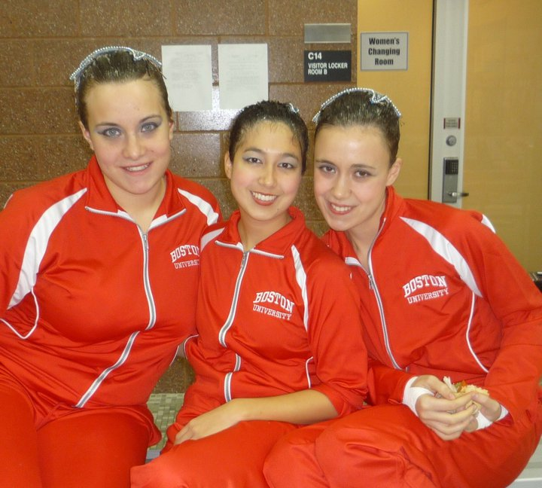

Write captions for the selected photos.

November 2011

­

Volume #1 issue #1

­

Coaches Corner

*For the friends and family less familiar with Synchro, here are the basics.*

­

**Sculls**

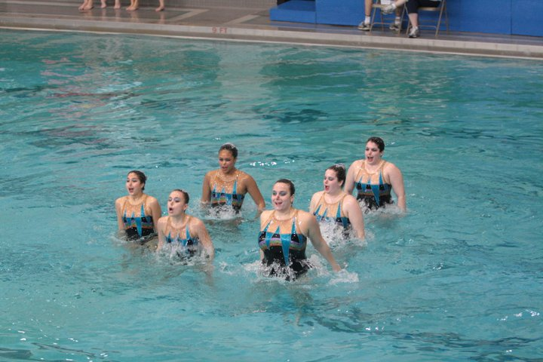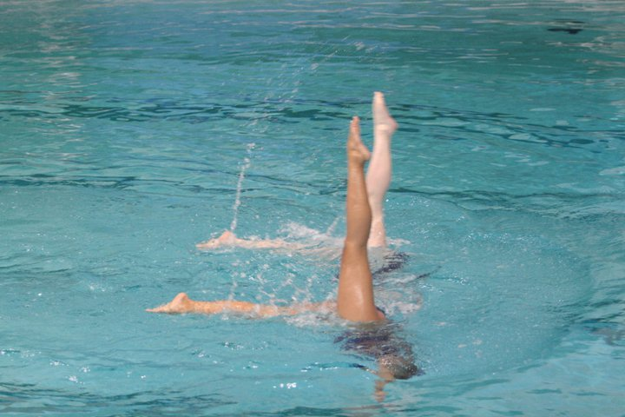

Sculls (hand movements used to propel the body) are the most essential part to synchronized swimming. Commonly used sculls include support scull, standard scull, torpedo scull, split-arm scull, barrel(or shuffle) scull, and paddle scull. The support scull is used most often to support the body while a swimmer is performing upside down. Support scull is performed by holding the upper arms against the sides of the body and the lower arms at 90-degree angles to the body. The lower arms are then moved back and forth while maintaining the right angle. The resulting pressure against the hands allows the swimmer to hold their legs above water while swimming.  This scull takes a while to master.

**Eggbeater**

The "[eggbeater](http://en.wikipedia.org/wiki/Treading_water" \l "Eggbeater_kick" \o "Treading water" \t "_blank) kick" is another important skill of synchronized swimming. It is a form of treading water that allows for stability and height above the water while leaving the hands free to perform strokes. An average eggbeater height is usually around chest level. Using the eggbeater, swimmers can also perform "boosts", where they use their legs to momentarily propel themselves out of the water to their hips or higher. "Eggbeater" is also a common movement found in water polo as well as the "pop-up" movement.

**Routine**

Routines are composed of "hybrids" (leg movements) and arm or stroke sections. They often incorporate lifts or throws, an impressive move in which a group of swimmers lift or throw another swimmer out of the water. Swimmers are synchronized both to each other and to the music. During a routine swimmers can never use the bottom of the pool for support, but rather depend on sculling motions with the arms, and eggbeater kick to keep afloat. After the performance, the swimmers are judged and scored on their performance based on technical merit and artistic impression. Technical skill, patterns, expression, and synchronisation are all critical to achieving a high score.

**C C** Co

**Contributed by Coach Eugenia Gillan**



*"If there's one thing a synchronized swimmer knows best, it's counting to 8."*

*Unknown*

Volume #1 issue #1

­

Write captions for the selected photos.

November 2011