EM 500 Emerging Media Studies/ CM 514 New Communication technologies*
EM 500: Introducing emerging and new media from a variety of perspectives, including historical, economic and psychological. Social science research perspectives on emerging media effects and policy issues surrounding emerging media form the second half of the course. Applications of theory to a variety of topics and social issues will be discussed.

CM 514: Course prepares students for careers in an environment of constant technological development and institutional change. Provides an overview of current and near-future developments in telecommunications; a theoretical base and exercise in systems analysis for assessing the potential uses and importance of these technologies in media-related institutions; and consideration of legal, regulatory, and social issues which these technologies and their uses may raise for telecommunications and media industries and society in general.

Week 1 (9/12) – Introduction to emerging media

Jenkins, H. (2004). The Cultural Logic of Media Convergence. International Journal of Cultural Studies, 7; 33.

“Media convergence is more than simply a technological shift. Convergence alters the relationship between existing technologies, industries, markets, genres and audiences.”

Week 2 (9/19) – History of emerging media

Beniger, J. (1986). Toward an old new paradigm: The half-century flirtation with mass society. Public Opinion Quarterly, 51: S46-S66.

Summary of the mass society paradigm.

Gleick, J. (2011). The information. New York: Pantheon

Ch. 15, on the concept of information “anxiety.”

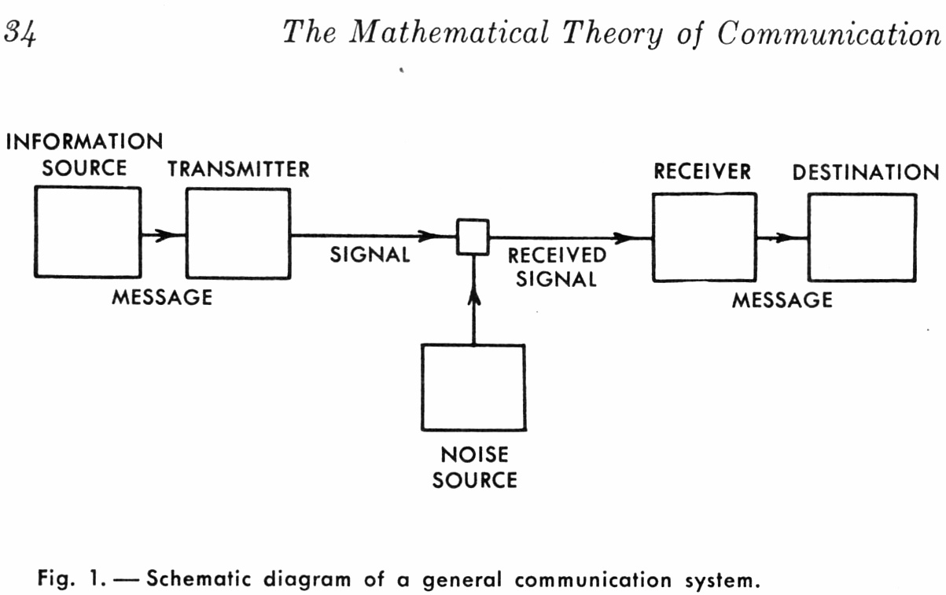

http://www-cs-faculty.stanford.edu/~eroberts/courses/soco/projects/1999-00/information-theory/history.html

TASK: design and create a telegraph system. No electricity may be used.

Week 3 (9/26) – Economics of emerging media

Anderson, C. (2006). The long tail. New York: Hyperion.

Ch. 8, Market diversity expands in the new media environment.

Napoli, P. (2008). Toward a model of audience evolution: New technologies and the transformation of media audiences. New York: Columbia University Press.

Evolving approaches for measuring and conceptualizing audiences in a new media environment.

Week 4 (10/3) – Sociology of new media – Examining networks

DiMaggio, P. Hargittai, E., Neuman, R., & Robinson, J. (2001). Social Implications of the Internet
Annual Review of Sociology, 27: 307-336

“The Internet tends to complement rather than displace existing media…”

Haythornthwaite, C. (2002). Strong, weak, and latent ties and the impact of new media. The Information Society: An International Journal, 18(5): 385 – 401.

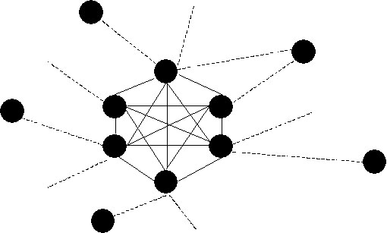

http://www.zylstra.org/blog/archives/2004/02/lurking_and_soc.html

SUGGESTED READING:

Katz, J., & Rice, R. (2002). Social consequences of Internet use: Access, involvement, and interaction. Cambridge: MIT Press

Major survey of Internet use.

Turkle, S. (2011). Alone together. New York: Basic Books

Online and disconnected.

TASK: assess the usability and accuracy of three different systems for depicting and analyzing social networks.

Week 5 (10/10) – Technological determinism and other theories of technology

Hughes, T. (1987). The evolution of large technological systems. In Bijker, W., Hughes, T. & Pinch, T. The social construction of technological systems: New directions in the sociology and history of technology. Cambridge: MIT Press.

Social construction of technology. (This text is also available online at the BU Library; use “ebrary” reader)

Marx, L. (1994). The idea of “technology” and postmodern pessimism. In Smith, M. R., & Marx, L. (1994). Does technology drive history? Cambridge, MA: MIT Press, 1994.

“…an increasingly pessimistic sense of the technological determination of history.”

Week 6 (10/17) – New media policy

Gillespie, T. (2009). Wired shut. Cambridge: MIT Press.

“...instead of specifying what can and cannot be done legally with a copyrighted work, this new approach calls for the strategic use of encryption technologies to build standards of copyright directly into digital devices so that some uses are possible and others rendered impossible.”

Zittrain, J. (2006). The generative Internet. Harvard Law Review, 119(7): 1974-2040

“…the Internet is better conceptualized as a generative grid that includes both PCs and networks rather than as an open network indifferent to the configuration of its endpoints.”

Week 7 (10/24) – New media and media effects
Nass, C., & Moon, Y. (2000). Machines and mindlessness: Social responses to computers. Journal of Social Issues, 56: 81-103.
“The first set of studies illustrate how individuals over-use human social categories, applying gender stereotypes to computers and identifying with computer agents that share their ethnicity. The second set of experiments demonstrate that people exhibit over-learned social behaviors such as politeness and reciprocity with respect to computers. In the third set of studies, premature cognitive commitments are demonstrated: A television set labeled a specialist is perceived as providing better content than a television set that provides multiple types of content. A final series of studies demonstrate the depth of social responses with respect to computer “personality.”
Reeves, B., & Nass, C. (1996). The media equation. Cambridge: Cambridge University Press.

People respond to devices as if they were other people.

Sundar, S. S. (2004). Theorizing interactivity’s effects. The Information Society, 20: 385-389.
“… interactivity is an attribute of the technology and not that of the user. It exposes the tautology of studying the effects of perceived interactivity and calls for the consideration of ontological aspects that constitute interactivity while specifying its social and psychological effects.”
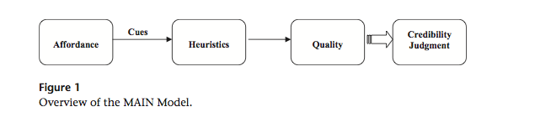
Sundar, S. S. (2008). The MAIN model: A heuristic approach to understanding technology effects on credibility. In M. J. Metzger & A. J. Flanagin (Eds.), Digital media, youth, and credibility (pp. 72-100). Cambridge, MA: The MIT Press.

Williams, D. (2006). Virtual cultivation: Online worlds, offline perceptions. Journal of Communication, 56(1): 69-87.

Videogames, violence, and effects.

TASK: design and implement a survey (online) that assesses an effect of use of any medium.

Week 8 (10/31) – New media and education
Gay, G., Stefanone, M., Grace-Martin, M., & Hembrooke, H. (2001). The effects of wireless computing in collaborative learning environments. International Journal of Human-Computer Interaction, 13(2): 257-276.

“The relative prevalence of social computing increased and became more exclusive for students in the communication course, especially on the wireless network. Social computing and use of the wireless network were less prominent and influential for students in the computer science course.”

Ito et al., (2008). Living and learning with new media: Summary of findings from the digital youth project. The John D. and Catherine T. MacArthur Foundation Reports on Digital Media and Learning.

“Today’s youth may be coming of age and struggling for autonomy and identity as did their predecessors, but they are doing so amid new worlds for communication, friendship, play, and self-expression.”

Week 9 (11/7) – New media and political communication

Castells, M. (2007). Communication, Power and Counter-power in the Network Society. International Journal of Communication 1: 238-266.

“…mass media and horizontal communication networks are converging. The net outcome of this evolution is a historical shift of the public sphere from the institutional realm to the new communication space.”

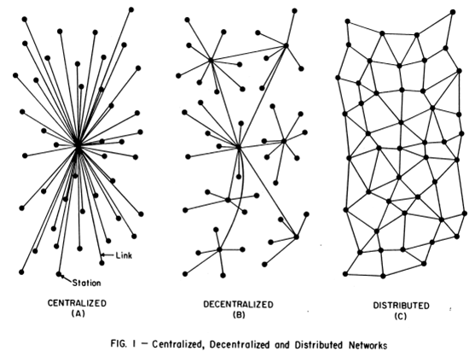
http://cb3blog.files.wordpress.com/2009/12/hypodermic-network.png

Garrett, R. K. (2009). Echo chambers online? Politically motivated selective exposure
among Internet news users. Journal of Computer-Mediated Communication, 14: 265-285.

“…opinion-reinforcing information promotes news story exposure while opinion-challenging information makes exposure only marginally less likely.”

Woolley, J. Limperos, A., & Oliver, M. (2010). The 2008 presidential election 2.0: A content analysis of user-generated political Facebook groups. Mass Communication & Society, 13: 631-652.
“Results indicated that group membership and activity levels were higher for Barack Obama than for John McCain. Overall, Barack Obama was portrayed more positively across Facebook groups than John McCain.”

TASK: content analyze social network feeds for commentary on the Massachusetts Senate election.

Week 10 (11/14) – Computer-mediated communication

Bordia, P. (1997). Face-to-face versus computer-mediated communication: A synthesis of the experimental literature. Journal of Business Communication, 34(1): 99-118.

“In general, discussions on CMC take longer, produce more ideas, and have greater equality of participation. There is reduced normative pressure and poorer comprehension of the discussion in CMC.”

Walther, J. (1996). Computer-mediated communication: Impersonal, interpersonal, and hyperpersonal Interaction. Communication Research, 23(1): 3-43.

“…recognizing that media sometimes facilitate communication that surpasses normal interpersonal levels, a new perspective on "hyperpersonal" communication is introduced.”

Week 11 (11/21) – New media and journalism

Boczkowski, P. J. (2010). News at work: Imitation in an age of information abundance.
Chicago: University of Chicago Press.
“…change in the amount of news available as well as how we consume it has been coupled with an unexpected development in editorial labor: rival news organizations can now keep tabs on the competition and imitate them, resulting in a decrease in the diversity of the news.”

TASK : The “hostile media phenomenon” (or perception) is a well-known effect that explains how partisans view issues as they are presented in the media. Design and implement a small experiment that would show whether emerging forms of news presentation are more or less susceptible to this effect.

Week 12 (12/5)– Social networking /social media

Boyd, D. M., & Ellison, N. B. (2007). Social network sites: Definition, history, and scholarship. Journal of Computer-Mediated Communication, 13: 210-230.
“Social network sites (SNSs) are increasingly attracting the attention of academic and industry researchers intrigued by their affordances and reach.”

Ellison, N. B., Steinfield, C., & Lampe, C. (2007). The benefits of Facebook “friends”: Social capital and college students’ use of online social network sites. Journal of Computer-Mediated Communication, 12: 1143-1168.
“Regression analyses conducted on results from a survey of undergraduate students (N=286) suggest a strong association between use of Facebook and the three types of social capital, with the strongest relationship being to bridging social capital.”

If we have time, additional content, may also be moved up…

Week 13 – New media and health

Chung, D. S., & Sujin, K. (2008). Blogging activity among cancer patients and their companions: Uses, gratifications and predictors of outcomes, Journal of the American Society for Information Science and Technology, 59(2), 297-306.
“…perceived credibility of blogs, posting comments on others' blogs, and hosting one's own blog significantly increased the explanatory power of the regression models for each gratification outcome.”

Eichhorn, K. C. (2008). Soliciting and providing social support over the Internet: An investigation of online eating disorder support groups. Journal of Computer-Mediated Communication, 14(1), 67-78.
“Results suggest that messages providing informational support were more prevalent than those providing instrumental support. Also, the findings revealed that the most frequent strategy for soliciting support was sharing experiences and the most frequent theme was positive affect.”

Week 14 – Gaming

Sherry, J. (2001). The effects of violent videogames on aggression: A meta-analysis. Human Communication Research, 27(3): 409-431.

“Results suggest there is a smaller effect of violent vidogames on aggression than has been found with television violence on aggression.”
Anderson, C. (2003). An update on the effects of playing violent videogames. Journal of Adolescence, 27:113-122.

“…exposure to violent video games is signiﬁcantly linked to increases in aggressive behaviour, aggressive cognition, aggressive affect, and cardiovascular arousal, and to decreases in helping behaviour. Experimental studies reveal this linkage to be causal. Correlational studies reveal a linkage to serious, real-world types of aggression.”

TASK : build a physical version of a videogame designed to be relaxing.

Evaluation

Attendance/participation/portfolio: 20%
Classroom presentation/”tasks”: 40%
Data analysis: 20%
Final project: 35%

Attendance is expected at every class. Student participation includes completing all readings, being able to lead discussion on any reading, responding to peer and professor comments and questions, and offering informed commentary. All student work from the class will be submitted in a digital portfolio.

Classroom presentation/tasks: On a periodic basis, the professor will assign students to complete “tasks.” These tasks will be assigned to groups, and group membership will rotate throughout the semester so that students may work in different combinations. Results from these tasks will be presented in class.

Also, students at any time will be expected to be able to lead discussion on readings for that week. Students are expected to have competencies in basic presentation skills.

Data analysis: On a rotating basis, students are expected to bring empirical data to support arguments and comments on the week’s readings. These assignments will be given to individuals. Students present these data to and receive comments.

Final project: The rest of your grade will be determined by your final project.

The paper will be a thesis/research paper on a topic of your choosing. This project will be completed in stages:

Week 3: proposal for topic, 1 page

You will submit a proposal for your topic. Because it is early in the semester, students will receive feedback on whether the topic is feasible, and/or how it can be changed. We will discuss possible topics and their feasibility in class.

Week 5: Annotated bibliography, page length may vary depending upon available literature

During and up to this period you will be conducting a literature review on the topic you wish to examine. You will collect relevant studies, and create an annotated bibliography, which means that each entry in the bibliography will be annotated by you as to the contents and implications of the various studies you cite. The format for the annotated bibliography will be provided.

Week 8: Literature review/proposal

During and up to this period, you will refine your annotated bibliography into a formal literature review and proposal. Taking the material you have gathered, you will construct a review of existing theories and findings, summarizing their strengths and weaknesses, leading up to formal research questions or hypotheses for your final paper. These hypotheses should reflect the ideas that you will examine in the remainder of your paper. Once your literature review is approved you will proceed to independent work on the remainder of your paper.

Final paper due at exam time.

Course policies

All work is due on the date noted. Please do not ask for incompletes. Papers should be completed using the APA style manual. All scholarly rules of honesty apply to this course. If you are in doubt about a given practice of citation, please see me.

Incomplete Coursework: If for reasons acceptable to the instructor a student fails to take the final examination or to complete any other required work within a course, he or she receives the I grade. Within the time limit set by the individual school or college, the student must complete the course requirements. If the student does complete the course requirements, the I grade is replaced with the appropriate letter grade.

Attendance: Students are expected to attend each class session unless they have a valid reason for being absent. Students may be required at any time to account for undue irregularity in attendance, either by personal explanation to their faculty advisor or dean or by written statement from a parent or another authority. Any student who has been excessively absent from a course may be required to withdraw from that course without credit. Students who expect to be absent from class for more than five days should notify their dean promptly.

Students absent from classes more than two days for illness should be under a doctor’s care. Students who are absent five days or more for illness should present to Student Health Services a certificate of fitness from their physician or be examined at the University Clinic.

Absence for Religious Reasons: According to Chapter 151C of the General Laws, Commonwealth of Massachusetts, any student in an educational or vocational training institution, other than a religious or denominational educational or vocational training institution, who is unable, because of his or her religious beliefs, to attend classes or to participate in any examination, study, or work requirements on a particular day, shall be excused from any such examination or study or work requirement, and shall be provided with an opportunity to make up such examination, study, or work requirement that may have been missed because of such absence on any particular day... No adverse or prejudicial effects shall result to students because of their availing themselves of the provisions of this section.

Examinations: Course examinations are given at the instructor’s discretion. Final examinations are given only during the scheduled examination period (dates are stated in the Calendar section of this site).

If the student fails a course, he or she cannot take a second examination until this course is retaken.

If a student is absent for good reason from a final exam and wants credit for the course, he or she must apply to the school or college for special examination privileges. The student must complete a special exam before the end of the semester immediately following the absence.

COM Plagiarism Statement: Plagiarism is the act of representing someone else’s creative and/or academic work as your own, in full or in part. It can be an act of commission, in which one intentionally appropriates the words, pictures, or ideas of another, or it can be an act of omission, in which one fails to acknowledge/document/give credit to the source, creator and/or the copyright owner of those works, pictures, or ideas. Any fabrication of materials, quotes, or sources, other than that created in a work of fiction, is also plagiarism. Plagiarism is the most serious academic offense that you can commit and can result in probation, suspension, or expulsion.

Taping: Please note that classroom proceedings for this course might be recorded for purposes including, but not limited to, student illness, religious holidays, disability accommodations, or student course review.

Note also that recording devices are prohibited in the classroom except with the instructor’s permission.

For reference to this and other policies, see the Boston University Undergraduate Bulletin: http://www.bu.edu/bulletins/und/item10.html

