Chopped Greek Salad

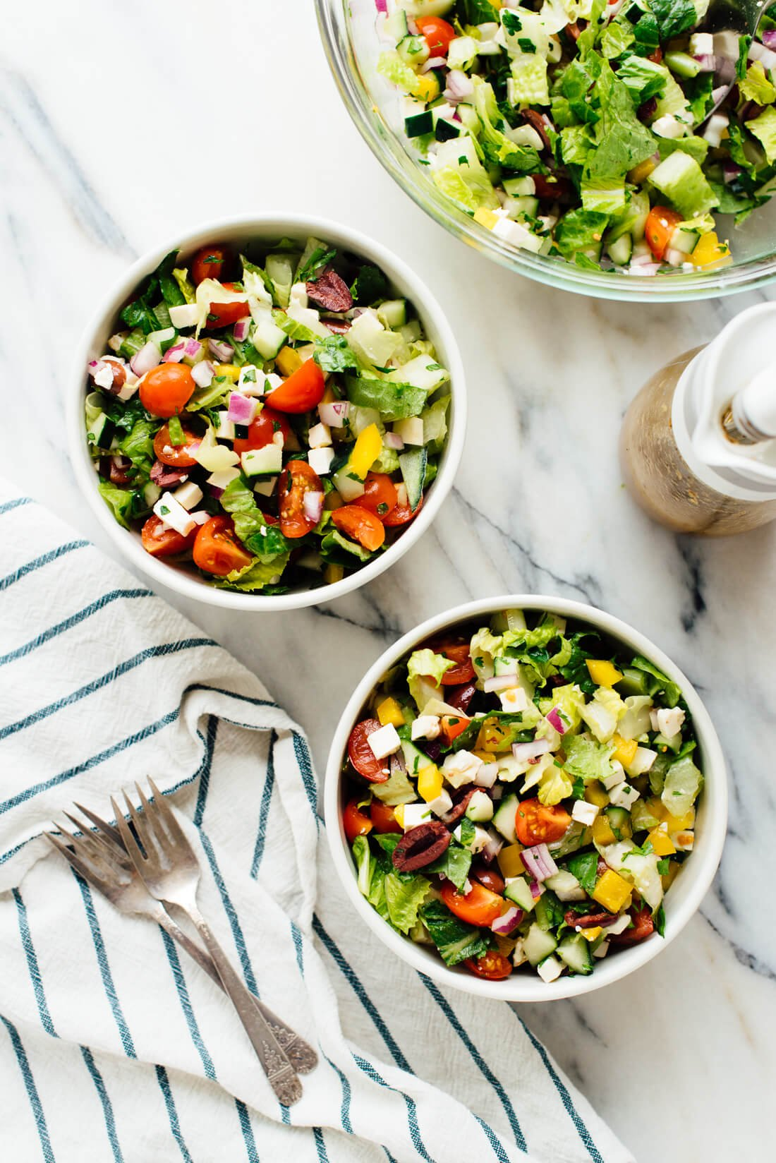
Makes: 8 Side Salads
Modified From CookieAndKate

INGREDIENTS
Salad:
- 10 ounces chopped romaine lettuce (about 2 medium or 3 small heads, chopped)
- 1 pint cherry tomatoes, quartered
- 1 medium cucumber (about 8 ounces), seeded and chopped
- 1 yellow or orange bell pepper (optional)
- ½ medium red onion, chopped (about 1 cup)
- ½ cup chopped fresh parsley
- ½ cup pitted and halved Kalamata olives
- 6 ounces feta cheese, sliced into ¼” cubes (about 1 ¼ cups)
Greek Vinaigrette
- ½ cup extra-virgin olive oil
- ¼ cup red wine vinegar
- 2 medium cloves garlic, pressed or minced
- 2 teaspoons dried oregano
- 1 teaspoon honey or maple syrup
- ½ teaspoon salt, more to taste
- Pinch of red pepper flakes, for heat (optional)

DIRECTIONS
- In a large serving bowl, combine the chopped lettuce, tomatoes, cucumber, pepper, onion, parsley, olives and feta. Toss the ingredients together and set aside
- To prepare the vinaigrette, combine all of the ingredients in a liquid measuring cup or a dressing mixer. Whisk until blended. Taste, and add more vinegar if you’d like a tangier dressing, or more honey for a sweeter dressing
- If you’ll be serving all of the salad at once, go ahead and drizzle enough dressing in to lightly coat the salad and toss to combine. Refrigerate dressing and salad separately.
- To make this a meal salad, add a whole grain (brown rice, bulgur wheat, farro, whole wheat pasta) and a protein (chicken, tofu, deli slices, beans, eggs, falafel).

LOW PREP/DORM RECIPE TIP:
When making this salad in your dorm, it may be easier to purchase pre-chopped peppers, onions, cherry tomatoes, and romaine lettuce so that there is minimal prep work. Store-bought Greek dressing can also be used.

