Shamrock Shake and Leprechaun Bait

Makes: 10 Servings
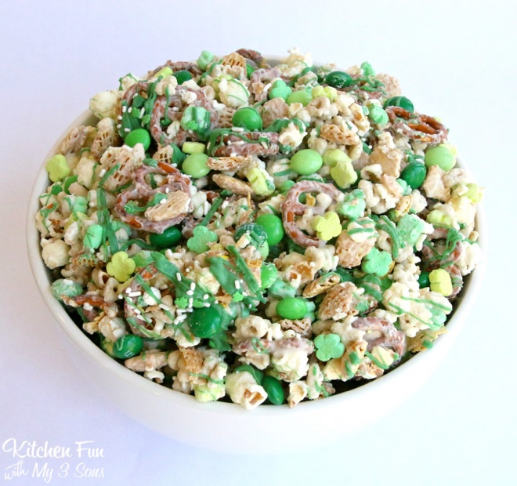
Modified from foodjoysunshine

INGREDIENTS
- 6 ounces white candy melts
- 3 ounces green candy melts
- 1.5 cups popcorn, popped
- 1.5 cups whole grain mini pretzel twists
- 1.5 cups brown rice Chex cereal
- 2 cups “More Whole Grain” Lucky Charms
- ½ cup Mint Dark Chocolate M&M’s
- ½ cup shelled pistachios
- St. Patrick’s Day sprinkles (optional)
- Green grapes or kiwi for serving

DIRECTIONS
- In a large bowl, combine Chex, Lucky Charms, pretzels, popcorn, pistachios and M&M’s. In a heat-safe bowl, melt the white chocolate in the microwave for 30 seconds. Stir and repeat until the chips are completely melted.
LOW PREP/DORM RECIPE TIP:
When making this recipe in a dorm, it may work best to split the recipe into two or three portions on wax paper. This will allow for enough room in the refrigerator or on your desk while the mixture sets. It also allows for easier storage.

- Pour the melted white chocolate over the cereal mixture. Stir carefully to combine, as to not crush the Chex. Stir until the mixture is completely coated with white chocolate.
- Pour mixture onto wax paper or parchment paper to dry and spread it out. Repeat with melting the green chocolate, then spoon over the mixture. Add the sprinkles.
- Allow to set until white chocolate has hardened and then break up into pieces.
- Store in an airtight container or enjoy immediately! Serve with shamrock shake, green grapes, or sliced kiwi fruit.

Shamrock Shake
Makes 4 Servings

1 cup milk
1 cup plain Greek yogurt
1 ½ teaspoons vanilla extract
2 Tablespoons honey
1 avocado
2 cups spinach (+additional as desired)
10-15 fresh mint leaves
½-1 cup ice (optional)
Additional honey to taste
Mini chocolate chips for garnish (optional)

1.Add ingredients to your blender in the order listed.
2.Blend, starting on low speed and gradually increasing to high until your mixture is smooth.
3.Pour and serve immediately with desired toppings.

