Valentine’s Raspberry Chocolate Bark

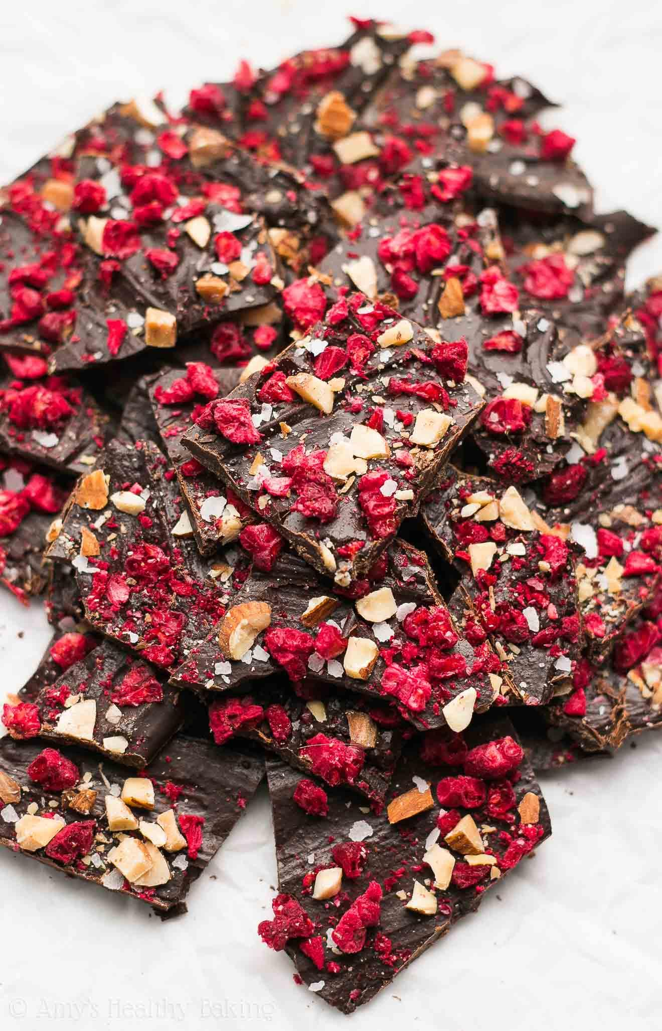
Makes: 8 Servings
Modified from AmysHealthyBaking

INGREDIENTS
- 4 oz unsweetened chocolate, roughly chopped
- 2 teaspoons sugar, or adjusted to taste
- ½ teaspoons vanilla extract
- ½ cup frozen or dried raspberries
- 2 tablespoons almonds or seeds, diced very finely (optional)
- ¼ teaspoons coarse sea salt

- DIRECTIONS
- Line a baking sheet with a silicone baking mat or parchment paper.
- Add the chocolate, sugar and vanilla to a microwave safe bowl and stir to combine. Microwave on high for 30 seconds. Stir with a fork for at least 2 minutes. If there are still small bits of un-melted chocolate, continue to microwave until the chocolate is completely melted and smooth.
- Immediately transfer the chocolate to the prepared baking sheet and spread it into a thin layer about 1/16” thick with a spatula. Quickly sprinkle the remaining ingredients on top, and gently press them down into the melted chocolate with your hands. Let the chocolate cool and harden completely in the freezer before breaking into small pieces.
LOW PREP/DORM RECIPE TIP:
This dessert is very simple to make, and can be done in the dorm room or with limited supplies! If you are working with a microfridge, be sure to use smaller baking sheets when freezing the chocolate bark so that they will fit into the freezer.

