Vegetable Dumplings
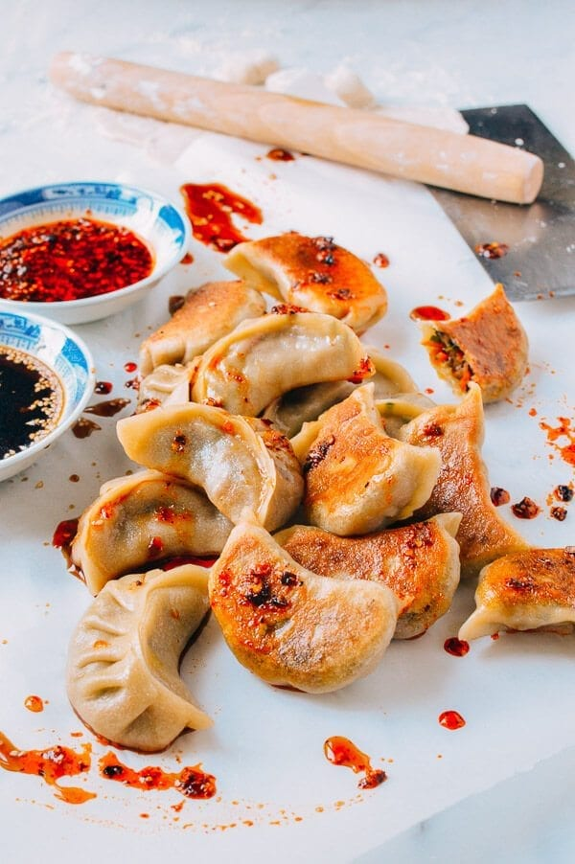
Makes: 10 Servings
Modified from TheWoksOfLife
INGREDIENTS
Dumpling Wrappers:
- 3 ½ cups white whole wheat flour
- 1 cup tepid water
Filling:
- 3 tablespoons olive oil (plus ¼ cup)
- 1 tablespoon minced ginger
- 1 large onion
- 2 cups shiitake mushrooms
- 2 cups finely shredded cabbage
- 2 cups finely shredded carrots
- 1 cup garlic chives, finely chopped
- ½ teaspoon white pepper
- 2 teaspoons sesame oil
- 3 tablespoons Shaoxing wine, dry sherry, or rice wine vinegar
- 2 tablespoons low sodium soy sauce
- 1 teaspoon sugar
- Salt (to taste)
DIRECTIONS

- Start by making the dough for the dumpling wrappers. Put the flour in a large mixing bowl, gradually adding water and kneading into a smooth dough. This process should take about 10 minutes. Cover with a damp cloth and let the dough rest for an hour.
- Next, make the filling. Add 3 tablespoons olive oil and the ginger to a large skillet over medium high heat for 30 seconds, or until fragrant. Stir in the onions until translucent.
- Add the chopped mushrooms and stir-fry for another 3-5 minutes, until the mushrooms are tender, and any liquid released from the mushrooms has cooked off.
- Add the cabbage and carrots and stir-fry for another 2 minutes, until the veggies are tender, and all the liquid released has been cooked off. Transfer this mixture to a large mixing bowl and allow to cool.
- Add the chopped chives, white pepper, sesame oil, shaoxing wine, low sodium soy sauce, and sugar. Season with salt to taste and stir in the last ¼ cup of olive oil.
- To assemble the dumplings, cut the dough into small tablespoon-sized pieces. Roll each out into a circle and pleat the dumplings. Assemble until you run out of dough or filling.
- To cook, steam or pan-fry the dumplings. To steam, put the dumplings in a steamer lined with a bamboo mat, cabbage leaf, or cheese cloth and steam for 15-20 minutes.
- To pan-fry, heat 2 tablespoons of olive oil in a non-stick pan over medium high heat. Place the dumplings in the pan and allow to fry for 2 minutes. Pour a thin layer of water into the pan, cover, and reduce to medium-low heat. Allow dumplings to steam until the water has evaporated. Remove the cover, increase the heat to medium-high, and fry for a few more minutes, until the bottoms of the dumplings are golden brown and crisp.
LOW PREP/DORM RECIPE TIPS
If you do not have access to a cooktop or hot plate, try frozen vegetable dumplings. Trader Joe’s sells microwavable frozen vegetable dumplings, as do many large grocery stores. Serve with a side salad with protein such as tofu, beans, or chicken.

