
We asked Kimberly Fowler, founder of YAS Fitness Centers in California and creator of YOGA for ATHLETES, to share her ultimate yoga moves for strengthening and protecting your major muscle groups head to toe.
No matter your sport, include these poses into your program and make it through the seasons injury-free.
If you’re already injured, only try the Rehab and Injury Poses and be sure to talk to your doctor before beginning any new exercise program.
How to use the poses below.
Hold all of the poses at least 60 seconds and work up to three minutes. In Fowler’s class students hold each pose for the full three minutes. Despite moans and complaints the longer you hold the pose she says, the quicker you reap the benefits. These poses are meant to be part of your cool down or rehab so use them after your workout or on off days.
Back to article
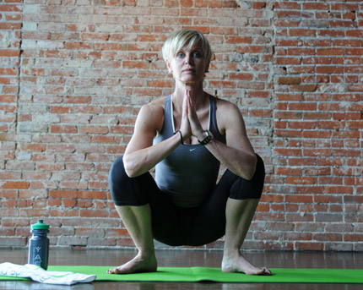

Trouble Spot: Shins
Prevent Injury: Squat (Garland Pose) (Malasana)
1. Stand with your feet hip-width apart, feet are parallel and toes are pointing forward. Turn your toes slightly out, about 45 degrees.
2. Bend your knees and squat down towards the floor as far as is comfortable for you. Aim to get your butt as close to the floor as possible. Bring your hands together in front of your chest in prayer position.
3. Hold for 30 to 60 seconds, then place your hands on your hips and slowly come up. You can also place your hands on your thighs to help push you up.
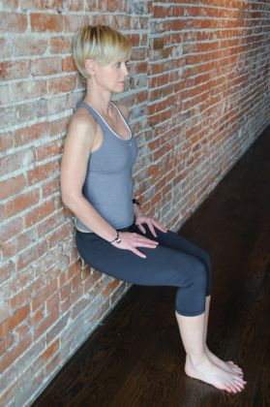

Trouble Spot: Shins
Rehab an Injury: Chair (modified up against the wall) (Utkatasana)
1. Stand against a wall with your back straight, arms hanging by your side. Scoot your butt down until your thighs are parallel with the floor. Bring your feet out in line with your knees.
2. Place your hands against the wall, fingers pointing toward the floor. “Using a wall for support helps take added pressure off of your shins, but you still benefit from the stretch,” notes Fowler. Or you can modify it by placing your hands on top of your thighs, as pictured here.
3. Hold for 30 to 60 seconds, then slowly raise yourself up and push yourself off the wall to come to standing.
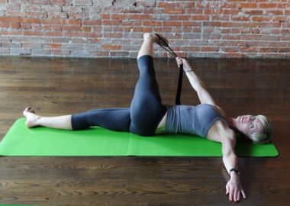

Trouble Spot: IT band
Prevent Injury: Reclining Foot Pose
Note: You'll need a strap or a towel
1. Sit on the floor, bring your legs out in front of you and lie down. Bring your left leg straight up into the air. Grab your left foot with your right hand. If you can’t quite reach your foot, use a towel or a strap and wrap it around your foot.
2. Bring your left arm straight out to your side, palm flat on the floor, to stabilize yourself. Take your left foot towards your right side so your left leg comes across your body. Then, bring your leg as far down toward the floor as is comfortable for you.
3. Hold for 30 to 60 seconds, then come back to lying down and repeat on the opposite side.
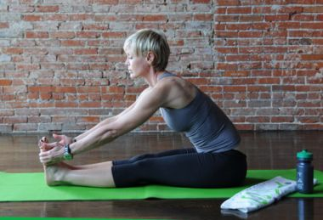

Trouble Spot: IT band
Rehab an Injury Pose: Seated Forward Bend
Note: You'll need a strap or a towel
1. Sit on the floor. Bring your legs out straight in front of you, keeping legs together and feet flexed, toes pointing back toward your face. “Keeping your feet flexed really helps work the IT band, especially in runners or cyclists who tend to be really tight in this area,” says Fowler.
2. Reach up with your arms and slowly hinge your body forward and down, extending out over your legs. Try to reach and hold onto your toes, or wrap a strap or a towel around the arches of your feet and hold onto the near ends. Keep your feet in a neutral position so they’re not rolling in or rolling out--this will help prevent further aggravating the injury.
3. Hold for 30 to 60 seconds, then bend your knees and slowly come up to standing.
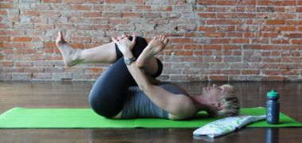

Trouble Spot: Hip Flexors
Prevent Injury: Pigeon Pose (Modified) (Eka Pada Rajakapotasana)
1. Lie down on your back. Bring your knees into your chest. Cross your right leg over your left thigh so the side of your right ankle rests against the top of your left thigh. (Your legs will look like the number 4).
2. Reach your right arm through the hole formed by your legs and grab your left shin with both hands. If you can’t quite reach your shin, grab the back of your left thigh, creating a gentle stretch by pulling the leg toward your body.
3. Hold for 30 to 60 seconds, then drop your right foot to the ground and repeat on opposite side.
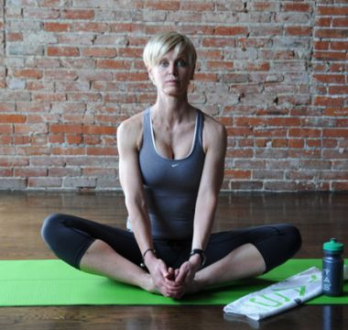

Trouble Spot: Hip Flexors
Rehab an Injury: Cobbler's Pose (Baddha Konasana)
1. Sit on the floor. Bring your legs straight out in front of you, place the soles of your feet together, knees wide apart. Bring your feet closer to your body.
2. If your injury prevents you from doing this, you can also bring your feet further away from your body to lessen the intensity of the stretch. Depending on your flexibility, you can try slowly walking your hands straight out in front of you, keeping your spine straight and lowering your chest toward the floor.
3. Hold for 30 to 60 seconds, then bring your knees together and slowly sit up.
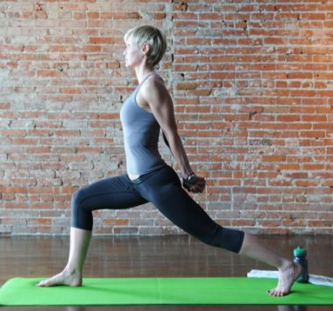

Trouble Spot: Plantar Fasciitis
Prevent Injury: Crescent to Warrior III (modify by bringing hands to the wall)
1. Start in Downward Dog. Bring your right leg forward, placing the foot between your hands. Come up on the ball of left foot.
2. From here, bring your hands behind you and clasp your arms together. Shift your weight forward, keeping your right knee bent until you stabilize yourself.
3. Straighten your leg and come into Warrior III, so your body looks like a T. You can keep your arms behind you or bring them straight out to your side or in front of you. For stability you can also place your hands on a wall or use a rail. “You’ll still work on strengthening the foot, but it helps you not be so wobbly so it’s easier for you to hold,” says Fowler.
4. Hold for 30 to 60 seconds, then slowly drop your right leg, and bend your knees to release your lower back. Step back into Downward Dog and repeat on opposite side.
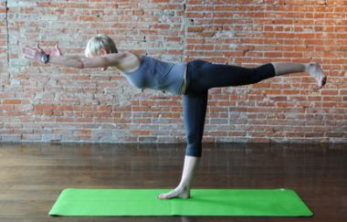

Trouble Spot: Plantar Fasciitis
Prevent Injury: Crescent to Warrior III (modify by bringing hands to the wall)
1. Start in Downward Dog. Bring your right leg forward, placing the foot between your hands. Come up on the ball of left foot.
2. From here, bring your hands behind you and clasp your arms together. Shift your weight forward, keeping your right knee bent until you stabilize yourself.
3. Straighten your leg and come into Warrior III, so your body looks like a T. You can keep your arms behind you or bring them straight out to your side or in front of you. For stability you can also place your hands on a wall or use a rail. “You’ll still work on strengthening the foot, but it helps you not be so wobbly so it’s easier for you to hold,” says Fowler.
4. Hold for 30 to 60 seconds, then slowly drop your right leg, and bend your knees to release your lower back. Step back into Downward Dog and repeat on opposite side.
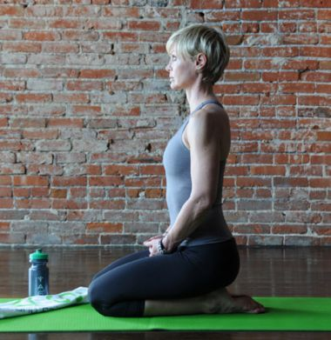

Trouble Spot: Plantar Fasciitis
Rehab an Injury: Diamond Pose
1. Kneel down on the floor. Bring your feet together behind you, toes pointing straight back. Sit back on your feet. “Diamond Pose is especially good for people who’ve injured this area because often they can’t really do standing poses,” notes Fowler.
2. Hold for 30 to 60 seconds, then curl your toes under and slowly stand up. If your injury isn’t quite so bad, you can also try coming up onto your toes as you do so to stretch your feet out in the opposite direction.
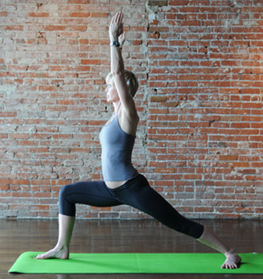

Trouble Spot: Knee
Prevent Injury: Warrior I (Virabhadrasana I)
1. Start in Downward Dog. Swing your right leg forward, stepping it between your hands. Drop your left heel flat on the floor.
2. Come up to standing with your front leg bent at a 90-degree angle, making sure your front knee is in line with your ankle to help strengthen the muscle around the bent knee. (You don’t want the knee to extend out in front of the foot.) Square your hips and torso forward. Bring your arms straight up to the ceiling in line with your ears, palms facing each other.
3. Hold for 30 to 60 seconds, then bring your hands down to either side of the front foot and step back into Downward Dog. Repeat on opposite side.
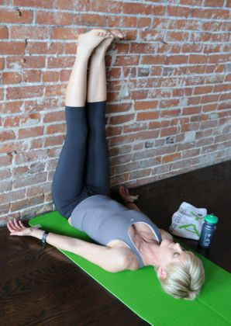

Trouble Spot: Knee
Rehab an Injury: Legs Up The Wall Pose (Viparita Karani)
1. Sit on the floor with your left hip against a wall. Lie down and swing your legs up, placing the backs of the legs against the wall. Try to keep your entire back flat on the floor, shoulders and neck in a comfortable position. Keep your hands resting by your sides.
2. Hold for at least 1 minute, then bend knees and slowly lower your legs to the left and return to sitting.
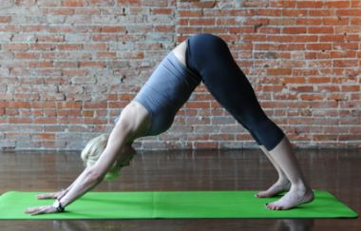

Trouble Spot: Sore Muscles
Prevent Injury: Downward Dog (Adho Mukha Svanasana)
1. Start on all fours. Bring your hands shoulder-width apart, knees hip-width apart. Straightening the arms and legs, push yourself up into an inverted V, keeping your feet the same distance apart as they were on all fours. (Hint: Think “butt up, heels down.”)
2. Hold for 30 to 60 seconds, then slowly come back down to all fours and stand up. “This is a really good move for both the chest area and the backs of the legs, both spots which are especially tight in athletes,” says Fowler.
3. To deepen the stretch for your chest and shoulders, bend both knees. To deepen the stretch for your hips and legs, bend alternating knees.
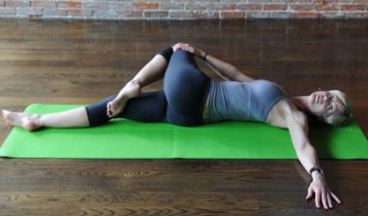

Trouble Spot: Sore Muscles
Rehab an Injury: Spinal Twist
1. Lay down on the floor. Bring both knees in toward your chest. Grab hold of your left knee keeping it near your chest and bring your right leg straight out in front of you. Hold your left, bent knee with your right arm and bring it across your body towards the right.
2. Reach your left arm straight out to your side, palm facing down. Look towards your left shoulder. “You’ll get a nice, complete total-body twist for lower back, hip and neck,” says Fowler.
3. Hold for 30 to 60 seconds. Bring both knees back into your chest to release tension in lower back. Repeat on opposite side.

