Cherry Lime Bread

Makes: 16 Servings
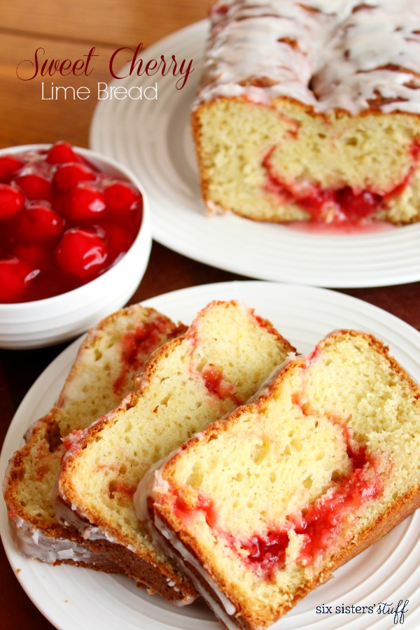
Modified from SixSistersStuff

INGREDIENTS
Bread:
- ½ cup unsalted margarine or butter, softened
- 1 cup sugar
- 3 eggs
- 2 cups white whole wheat flour
- 1 ½ teaspoons baking soda
- 2 teaspoons baking powder
- ½ teaspoon salt
- 1 teaspoon vanilla
- 1 lime zested, 1 lime juiced
- 1 ½ cups plain Greek yogurt or alternative
- 1 can no sugar added cherry filling or jam (21 oz)
Frosting:
- 2 juiced limes, 2 zested limes
- 1 tablespoon margarine or butter, softened
- 2 tablespoons milk, or alternative
- 1 ½ cups powdered sugar

DIRECTIONS
- Preheat the oven to 350 degrees and grease two 9 inch loaf pans.
- In a medium sized bowl, beat together the sugar, margarine, and eggs. Once combined, add the vanilla, lime juice, and lime zest.
- Fold in the Greek Yogurt or alternative.
- In a separate bowl, whisk together the whole wheat flour, baking soda, baking powder, and salt. Slowly add dry ingredients to the wet ingredients and mix until combined.
- Split the dough into four parts, placing ¼ of the dough into the bottom of each bread pan. Spoon ½ of the can of cherry pie filling into each bread pan and top the cherry pie filling with remaining dough in each pan. It’s ok if some of the dough and cherry pie filling mix together.
- Bake for 50-60 minutes, or until a toothpick comes out clean from the center of the bread. Remove the bread from the oven and let cool for at least 10 minutes.
- For the frosting, beat or whisk together margarine, milk or alternative, vanilla, and lime juice in a bowl. Slowly add in powdered sugar until you have reached your desired consistency.
- Remove bread from the pan and drizzle or pour frosting over the top of the bread.
- Slice, serve and enjoy!

LOW PREP/DORM RECIPE TIPS
Try this in the microwave! Pour ¼ cup of no sugar added cherry filling or jam in a microwave safe mug then sprinkle with 1 teaspoon of brown sugar (omit if using sweetened jam/filling).
In a separate bowl, mix 6 tablespoons white whole wheat flour and ⅛ teaspoon of cinnamon. Add one egg, 1 tablespoon of brown sugar, 1 teaspoon of vanilla, ¼ teaspoon of lime juice, and ¼ cup milk and stir well.
Pour this mixture on top of the fruit in the mug and microwave for 90 seconds. Use icing as listed previously to top the muffin.

