MaraMon French Toast Bake

Makes: 12 Servings
Modified from DinnerThenDessert
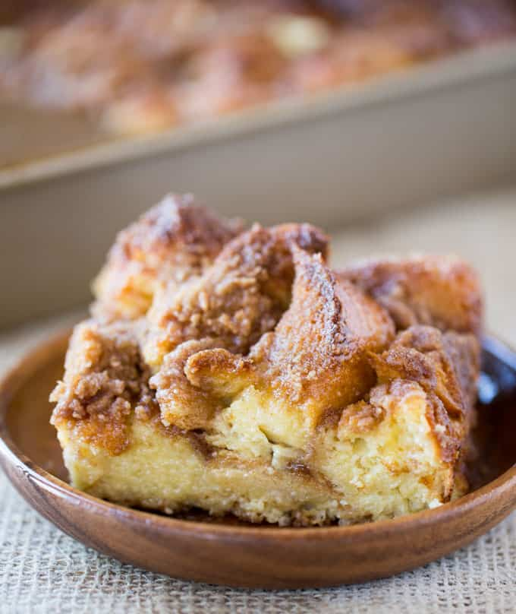
INGREDIENTS
Base Mix:
- 1 loaf whole grain bread (French or sourdough preferable)
- 8 eggs
- 2 1/2 cups milk or alternative
- ¼ cup sugar
- ½ cup brown sugar
- 1 tablespoon vanilla extract
- 2 teaspoons cinnamon
- ¼ teaspoon nutmeg
Topping:
- ½ cup whole wheat flour
- ½ cup brown sugar
- 1 teaspoon cinnamon
- ¼ teaspoon salt
- ½ cup margarine or butter
LOW PREP/DORM RECIPE TIPS
If you don’t have access to an oven, you can make this French toast in the microwave!
Ingredients:
1 tsp margarine
3 tbsp milk or alternative
1 tsp maple syrup
¼ tsp cinnamon
¼ tsp vanilla extract
1 pinch ground nutmeg
1 large egg
1 cup whole wheat bread pieces
Instructions:
1. Place the margarine in a large mug and microwave for 15-20 seconds, or until it is melted.
2. Add the milk or alternative, maple syrup, cinnamon, vanilla, nutmeg, and the egg to the mug and whisk until everything is well mixed.
3. Add the bread pieces to the mug and gently stir until all the pieces are saturated with the egg and milk mixture. Be careful not to stir too roughly or the bread pieces may fall apart.
4. Let the bread sit and absorb the liquid for about 1 minute. Microwave the mug for 60-90 seconds, or until the mixture is solid. Serve immediately, adding any fresh fruit toppings you would like.

DIRECTIONS
- Spray a 9x13 pan with cooking spray and preheat the oven to 350℉
- In a large bowl, add the eggs, milk or milk alternative, sugar, ½ cup brown sugar, vanilla, cinnamon, and nutmeg.
- Chop the whole wheat bread into ¾-1 inch cubes and put it in the bowl with the egg mixture. Toss well until all the liquid is absorbed into the bread.
- In a small bowl or a food processor, add the flour, remaining brown sugar, cinnamon, and salt and mix.
- Add the canola oil spread/margarine to the mixture and mix with a fork until crumbles form.
- Pour the bread mixture into the pan and cover evenly with the brown sugar mixture. Bake for 45-50 minutes or until the top is crispy and the center is no longer wet.
- Top with fresh fruit and serve. Bananas, blueberries, and strawberries work well.

