Versatile Summer Orzo Salad

Yields 4 – 6 servings
Adapted from and photo courtesy of FoodNetwork & thespicemarket
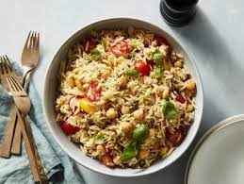
Ingredients:

- 1 cup uncooked whole wheat orzo
- 1 tablespoons turmeric
- 1 bunch of scallions (4-5 scallions)
- 1/2 cup feta cheese (crumbled)

Dressing:
- 1/3 cup olive oil
- ¼ cup red wine vinegar
- 1 tablespoon Dijon mustard
- salt & pepper to taste
- Lemon juice and honey optional to taste

Other seasonal ingredient ideas: summer squash, zucchini, eggplant, diced tomatoes, diced cucumbers, lemon juice & zest, spinach, dill, parsley

Crispy Chickpeas:
- 1 can chickpeas
- olive oil
- ½ tsp paprika
- ½ tsp oregano
- ½ tsp onion powder

- salt and pepper to taste
Directions
- Dressing: Mix vinegar, Dijon mustard, and olive oil in large bowl.
- Orzo: In a large saucepan, bring water and turmeric to a boil. Add the orzo and cook on low boil for 7-8 minutes until al dente, or according to package directions. Drain and transfer to bowl with dressing – mix well.
- While orzo is cooking, grill the scallions on a pan lightly coated with olive oil until the bulbs are tender and the greens and bulbs are browned, about 8 minutes. Chop scallions once cooled. Use similar method with any seasonal vegetables.
- Add feta and scallions to bowl with orzo, mix. If you have other seasonal veggies or herbs, mix in at this step.
- Set aside at room temperature for 1 hour to allow the flavors to blend or refrigerate. If refrigerated, taste again for seasonings and bring back to room temperature before serving.
- Heat chickpeas (rinsed and dried) on skillet for 6-8 minutes, stirring occasionally to prevent burning. Once browned, add seasonings and cook for another 2 minutes to warm and distribute flavors. Add to orzo salad or save for a snack!

Veggie Wrap With Pea Pesto

Makes: 4 Servings
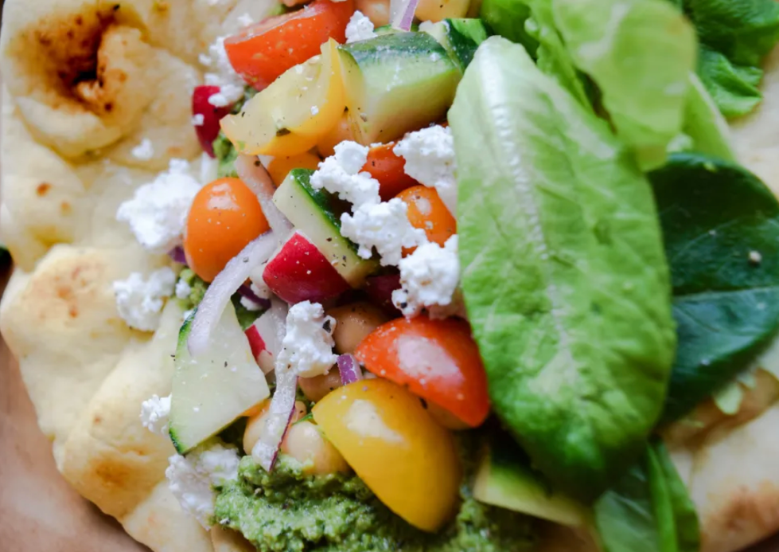
Modified from and photo courtesy of The Mountain Table

INGREDIENTS FOR PESTO:
- 1 Cup Sweet Peas (can use frozen or canned)
- 3/4 Cup Packed Basil Leaves
- 1/4 Cup Mint Leaves
- 1/4 Cup Sunflower Seeds
- 1 1/2 Tsp Salt
- 5-6 Tbsp Olive Oil

INGREDIENTS FOR VEGGIE WRAPS:
- 4 Pieces whole-grain Naan
- 3 Cups Chopped Veggies –grape tomatoes, cucumber, radish, red onion
- 1 can chickpeas (drained, rinsed)
- 2 Tbsp Olive Oil
- 2 Tbsp Lemon Juice
- To Taste Salt and Pepper
- Feta
- Lettuce (optional)

DIRECTIONS
- Add all the Pesto ingredients except olive oil to the base of a food processor or blender. Pulse, slowly drizzling in the oil until the texture becomes creamy. Set Aside.
- Preheat the oven to 350. Toast your naan bread in the oven for about 3-5 minutes until it becomes warm and soft.
- Chop veggies into bite size pieces. Combine in a large bowl with the olive oil, lemon juice, and salt and pepper to taste. Add in rinsed chickpeas and toss.
- Spread some pesto down the middle of your naan. Top each wrap with 1 cup of veggies and bean mixture. Sprinkle with feta. Top with lettuce (as desired) and enjoy!

LOW PREP/DORM RECIPE TIP:
Short on time? Purchase pre-cut vegetables, pesto, canned beans, and lemon juice. Combine topping ingredients in a bowl or Tupperware, and mix/shake. Add a spread of pesto to whole-grain naan, and top with bean/veggie mixture.

Quinoa Salad with Dried Fruit, Pepitas and Herbs

Yields 6 - 8 servings
Recipe adapted from and photo courtesy of Gaining Grounds cookbook

Ingredients:

- 1 cup quinoa
- 2 tbsp olive oil
- 2 tbsp lemon juice
- Zest of lemon and/or orange
- 2 scallions, thinly sliced
- 1 can garbanzo beans, drained and rinsed
- 1 large handful of fresh herbs: mint and parsley, finely chopped
- ¼ cup of dried apricots, diced
- ¼ cup golden raisins
- ½ cup seeds of choice (pepitas, sunflower, etc.)
- 3 oz crumbled goat or feta cheese (optional)
- Salt & pepper to taste

Note: amounts are a guide – feel free to adjust to your preference. This recipe can be adapted based on your favorite herbs, nuts, beans and vegetables, what you have on hand, or what is in season.

Directions:
- Rinse quinoa in fine mesh strainer (unless package indicates pre-rinsed).
- Bring 2 cups water and quinoa to a boil in a small saucepan over high heat to boil. Reduce to low heat for simmer and cook until the liquid is just absorbed, and the quinoa is moist and nearly tender, about 15 minutes. Take off heat and cover for 5 minutes. Quinoa is ready when the curly tail (germ) separates – tender but still slightly firm.
- Transfer the quinoa to a large bowl and fluff with fork, adding olive oil, lemon juice, zest, salt and pepper to taste. (make in advance option: refrigerate at this step. Continue with recipe when ready to serve)
- When the quinoa is cool and ready to serve, stir in the scallions, beans, fresh herbs, apricots, raisins and pistachios. Adjust seasoning to taste. Sprinkle with the goat cheese and serve.

Refreshing Blueberry Ginger Drink

Yields 2 servings
- 1/2 cup blueberries
- 1/2 tsp ginger
- 2 sprigs mint
- 1 can sparkling water (plain, lemon, or lime)
- Ice
Directions
Divide blueberries and ginger into two cups. Mash with spoon. Add sparkling water, ice, and sprig of mint to each glass. Squeeze in some lime or lemon juice or use flavored seltzer. Adjust amounts to your taste. Enjoy!

Vegetarian Breakfast Burrito

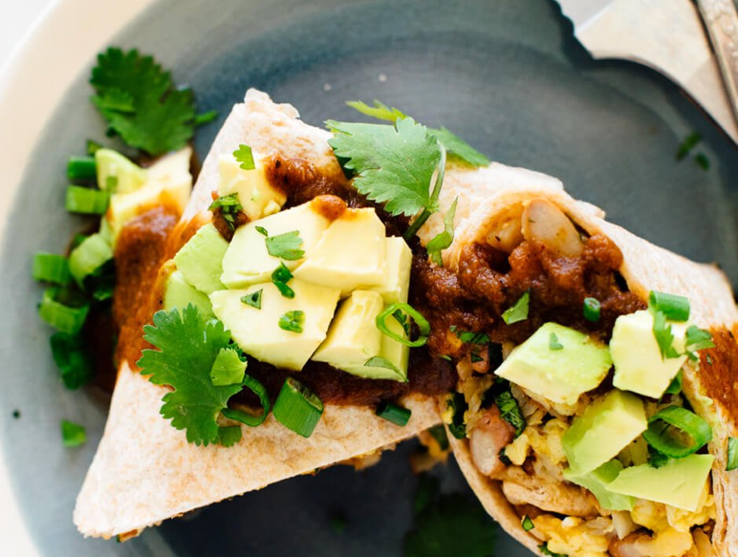
Makes: 6 Servings
Recipe modified & photo courtesy of Cookie and Kate

INGREDIENTS FOR BURRITOS:
- Six 6” whole-grain tortillas
- 1 Russet potato (cubed or shredded)
- 1 cup carrot (shredded or diced)
- 6 large eggs
- ½ can pinto beans or black beans (drained, rinsed)
- Black Pepper, Garlic Powder
- Several dashes of hot sauce
- 1 tablespoon olive oil
- 1 cup shredded sharp cheddar cheese
- ½ cup chopped cilantro
- 1 cup chopped green onion
- 6 tablespoons of salsa
- 1 large avocado, diced (optional)

DIRECTIONS
- Crack the eggs into a medium bowl and whisk them with a fork until pale yellow. Ensure shell pieces haven’t been left behind. Stir in the beans, and shredded carrot, add seasoning of choice and hot sauce.
- Place oil in a medium-sized skillet/pan over medium heat. Add potato cubes, and cook for approximately 3-5 minutes to soften the potatoes, flipping them throughout. Pour in the egg mixture and cook, stirring often, until the eggs are just set, about 2 to 4 minutes. Stir in the cheese and transfer the mixture to a bowl. Then stir in the cilantro and green onion (if you’re serving the burritos right away, reserve a small amount of each for garnish).
- Warm the tortillas briefly in the microwave (about 10 to 20 seconds) or in a skillet.
- Working with one tortilla at a time, spread egg mixture evenly between them. Drizzle 1 tablespoon salsa on top of the mixture. Leave about 1/3 of the tortilla exposed without any toppings.
- Roll up the burrito by first folding the tortilla over from the bottom to partially cover the contents, then fold in the two sides. Finish rolling and put the burrito seam side down on a plate.
- If you’re serving the burritos right away: Top with salsa, diced avocado (if using) and the reserved cilantro and green onion. Serve immediately, with a knife and a fork.
- If you’re freezing the burritos for later: Let the burritos cool to room temperature, then wrap each burrito in plastic wrap. Transfer the wrapped burritos to a freezer-safe bag and squeeze out the air before sealing. Store the burritos in the freezer. Consume your burritos within 3 to 6 months.
- To defrost frozen burritos, unwrap the plastic wrap and then wrap the burrito in a damp paper towel. Microwave about 2 to 3 minutes, until warmed throughout.

LOW PREP/DORM RECIPE TIP:
Consider purchasing a frozen burrito made with whole grains, a lean or plant protein, and add additional vegetables on the side.

Shredded Zucchini And Carrot Muffins

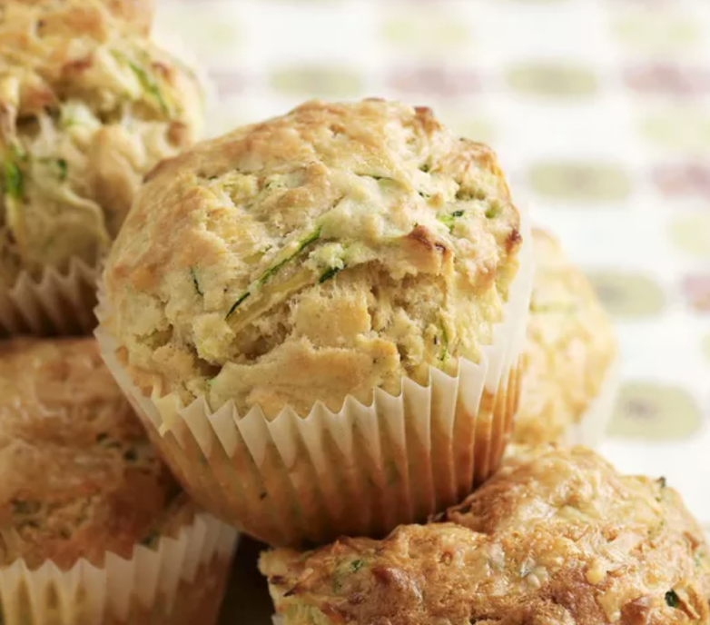
Makes: 12 Servings
Modified from and photo courtesy of The Spruce Eats

INGREDIENTS FOR CINNAMON SUGAR TOPPING
- 1/4 cup white sugar
- 1 tablespoon cinnamon

INGREDIENTS FOR MUFFINS:
- 2/3 cup vegetable oil
- 2 large eggs (room temperature)
- 1/2 cup white sugar
- 1/3 cup brown sugar (light or dark, packed)
- 1 teaspoon vanilla extract
- 2 cups white whole wheat flour
- 1/2 teaspoon baking soda
- 1/2 teaspoon baking powder
- 1/2 teaspoon salt
- 2 teaspoons ground cinnamon
- 1 1/2 cups zucchini (unpeeled, finely shredded)
- 1/2 cup carrot (peeled, finely shredded)

DIRECTIONS
- Gather the ingredients.
- Heat oven to 375 F. Grease and flour 12 muffin cups and set aside.
- Make the cinnamon sugar by combining ¼ cup white sugar with 1 tablespoon cinnamon and set aside.
- In a large mixing bowl, beat oil with eggs, white sugar, brown sugar, and vanilla extract until well combined.
- In a separate medium bowl, whisk together flour, baking soda, baking powder, salt, and cinnamon.
- Add dry ingredients to the wet ingredients, stirring until no streaks of flour remain, but do not overmix.
- Fold in the shredded zucchini and carrots until completely incorporated.
- Fill muffin cups about 3/4 full; sprinkle with cinnamon sugar, if desired.
- Bake muffins for 20 minutes or until a toothpick inserted in the center comes out clean.
- Remove from oven, wait 5 minutes before turning out onto a wire rack to cool slightly before serving.

LOW PREP/DORM RECIPE TIP:
Add nut or seed butter to this (or a store-bought) muffin for lasting satiety and consider adding a piece of fruit on the side for additional filling power!

Thai Pumpkin Coconut Curry

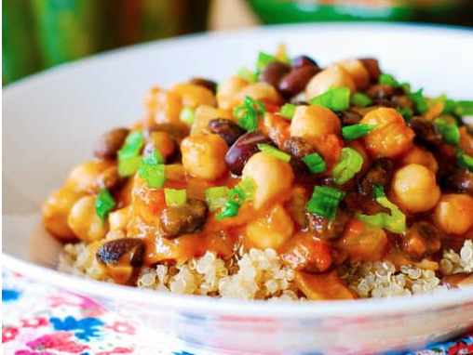
Makes: 4 Servings
Modified from and photo courtesy of Julia’s Album

INGREDIENTS FOR CURRY:
- 1 tablespoon olive oil
- 1 onion, chopped
- 4 cloves garlic, minced
- 1 cup canned pumpkin puree
- 1 cup tomatoes (fresh or canned, diced)
- 1 cup vegetable stock (or water)
- 1/4 cup coconut milk (can sub regular milk)
- 1, 15 oz can black beans (rinsed and drained)
- ½ can garbanzo beans (rinsed and drained)
- 2 tablespoons red curry paste (amount to taste for desired spice)
- 3 tablespoons honey (or can use agave nectar or maple syrup)
- Salt and pepper to taste
- 2-3 cups cooked quinoa

DIRECTIONS
- In a large pot or skillet, cook chopped onion and minced garlic in olive oil for about 5 minutes on medium heat until soft.
- Add to skillet: pumpkin, diced tomatoes, vegetable stock (or water), coconut milk, black beans, and garbanzo beans.
- Add 1 tablespoon of red curry paste, stir everything well, and season with salt and pepper. Taste and add another tablespoon of red curry paste, if desired.
- Add 1 -3 tablespoons of honey to taste, to balance flavors.
- Bring to a boil, make sure to stir all ingredients well together to combine flavors and spices.
- Reduce to a low simmer and cook for 15 minutes.
- Serve with quinoa. Option to garnish with chopped green onion.

LOW PREP/DORM RECIPE TIP:
Most ingredients come in a can for easy prep! Mix ingredients in a microwave-safe bowl, and microwave in 30 second increments, stirring between. Remove when curry has reached desired temperature and texture. Purchase microwave quinoa or brown rice for ease of cooking.

Apple Crisp

Makes: 8 Servings
Modified from and photo courtesy of Taste of Home

INGREDIENTS:
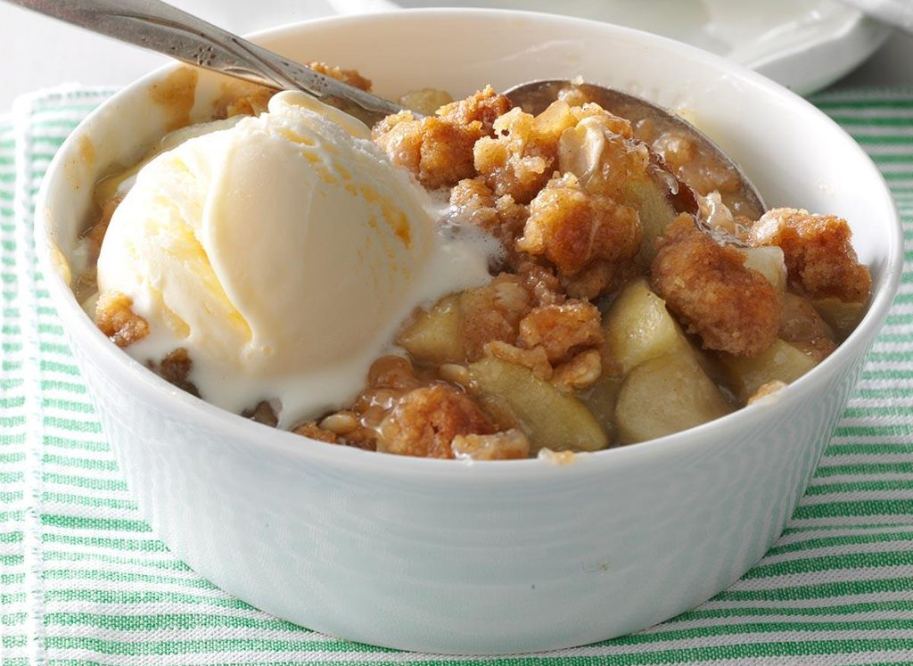
- 1 cup white whole-wheat flour
- ¾ cup rolled oats
- ¾ cup packed brown sugar
- 1 teaspoon ground cinnamon
- ¼ cup butter, softened
- ¼ cup canola oil
- 6 cups chopped peeled apples
- ¾ cup sugar
- 2 tablespoons cornstarch
- 1 cup water
- 1 teaspoon vanilla extract
- Yogurt for topping (optional)

DIRECTIONS
- Preheat oven to 350°. In a large bowl, combine flour, oats, brown sugar, and cinnamon. Cut in butter and mix in oil until crumbly. Press half into a greased 2-1/2-qt. baking dish or a 9-in. square baking pan. Cover with apples.
- In a small saucepan, combine the sugar, cornstarch, water and vanilla. Bring to a boil; cook and stir 2 minutes or until thick and clear. Pour over apples. Sprinkle with remaining crumb mixture.
- Bake 60-65 minutes or until apples are tender. Serve warm, with yogurt if desired.

LOW PREP/DORM RECIPE TIP:
Mix ingredients together in a microwave-safe bowl or mug (adjust quantities based on desired serving size). Microwave in 30 second increments, stirring between each, until apples are softened and warm.

Sesame Miso Ramen with Crispy Mushrooms

Makes: 4 Servings
Modified from and photo courtesy of Half-Baked Harvest

INGREDIENTS:
- 6 cups low sodium vegetable broth
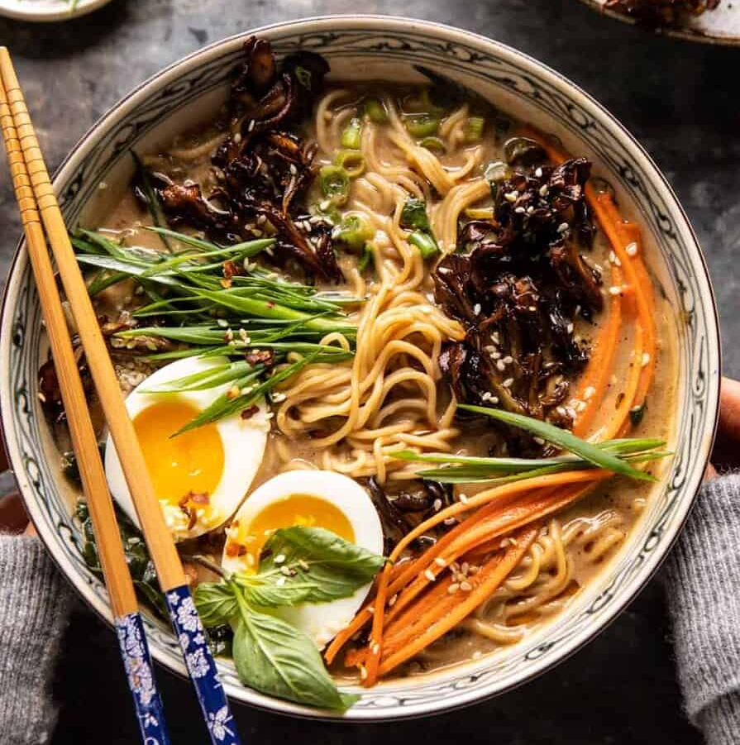
- 2 tablespoons low sodium soy sauce
- 2 tablespoons rice vinegar
- 1/4 cup tahini (sesame seed paste)
- 3 tablespoons white miso paste
- ¼-½ cup dried porcini mushrooms (optional, but recommended)
- 1-inch fresh ginger, grated
- 2 cloves garlic, minced or grated
- 2-4 squares whole-grain ramen noodles
- 4 cups shredded kale or baby spinach
- 4 tablespoons olive oil
- 2 pounds mixed mushrooms, roughly torn
- 2 small shallots, sliced
- 2 tablespoons raw sesame seeds
- 1/2 teaspoon chili flakes, to taste
- 1/4 cup fresh cilantro, chopped
- 4 soft- or hard-boiled eggs, for serving
Optional toppings: hot chili oil, sliced carrots and green onions, for serving

DIRECTIONS
1. In a large soup pot, combine the broth, 2 cups water, soy sauce, vinegar, tahini, miso, and chili oil (optional). Add the dried mushrooms (if using), ginger, and garlic. Set over medium heat on the stove and bring to a simmer, reduce the heat to medium-low and simmer 20 minutes, until the broth is very fragrant.
2. Remove and discard the mushrooms. Bring the soup to a boil over high heat. Stir in the noodles, kale or spinach, and cilantro. Let sit 5 minutes or until the noodles are soft.
3. Meanwhile, make the mushrooms. Preheat the oven to 425 degrees F. On a baking sheet, combine the olive oil, mushrooms, shallots, sesame seeds and chili flakes. Transfer to the oven and roast for 15 minutes, stirring halfway through cooking, until the mushrooms are golden. Switch the oven to broil, broil 1-2 minutes, until crisp. Watch closely.
4. Ladle the soup into bowls and top with the crispy mushrooms, eggs, carrots, green onions, and additional chili oil.

LOW PREP/DORM RECIPE TIP:
Jazz up microwave ramen with additional vegetables and a source of protein (eggs, chicken, beans, etc.)!

Baked Spinach & Artichoke Mac and Cheese

Makes: 6 Servings
Modified from and photo courtesy of Half-Baked Harvest
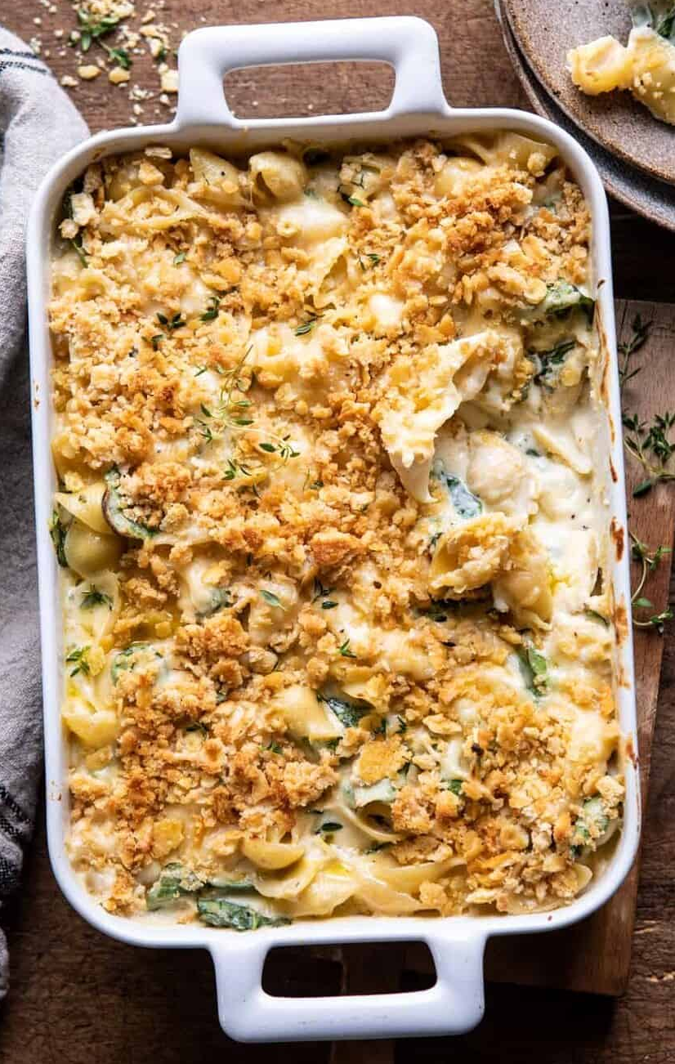
INGREDIENTS:
- 5 Tablespoons olive oil
- 1 (1-pound) box whole-wheat pasta (i.e. penne, macaroni, etc.)
- 2 cups milk
- 1 (8-ounce) package cream cheese, cubed
- 2 cups shredded sharp cheddar cheese
- Freshly ground pepper
- Ground cayenne pepper
- 4 cups packed fresh baby spinach, chopped
- 1 (8-ounce) jar marinated artichokes, drained and roughly chopped
- 1½ cups crushed whole-wheat Ritz crackers (about 1 sleeve)
- ¾ teaspoon garlic powder
Optional: Add protein of choice (package of tofu, 1 lb chicken/ground turkey, 1-2 can(s) beans, etc)

DIRECTIONS
1. Preheat the oven to 375 degrees F and grease a 9x13 inch baking dish.
2. In a large saucepan, bring 4 cups of water to a boil over high heat. Add the pasta and cook, stirring occasionally, for 8 minutes. Stir in the milk and cream cheese and cook until the cream cheese has melted, and the pasta is al dente, about 5 minutes more.
3. Remove the pan from the heat and stir in 1 ½ cups of the cheddar and 2 tablespoons of the olive oil. Season with pepper, and cayenne. Stir in the spinach and artichokes. If the sauce feels too thick, add small amounts of milk or water to thin it. Add protein of choice, if including.
4. Transfer the mixture to the prepared baking dish. Top with the remaining cheddar.
5. In a medium bowl, stir together the crackers, the remaining 3 tablespoons of oil, and the garlic powder. Sprinkle the crumbs evenly over the mac and cheese.
6. Bake until the sauce is bubbling, and the crumbs are golden, about 20 minutes. Let cool for 5 minutes and serve.

LOW PREP/DORM RECIPE TIP:
Try a whole-grain microwave mac and cheese cup, adding in a handful of spinach and protein of choice (tofu, beans, chicken, etc).

Roasted Butternut Squash, Pomegranate and Wild Rice Stuffing

Makes: 6 Servings
Modified from and photo courtesy of Cookie + Kate

INGREDIENTS:
- 2 cups wild rice, rinsed
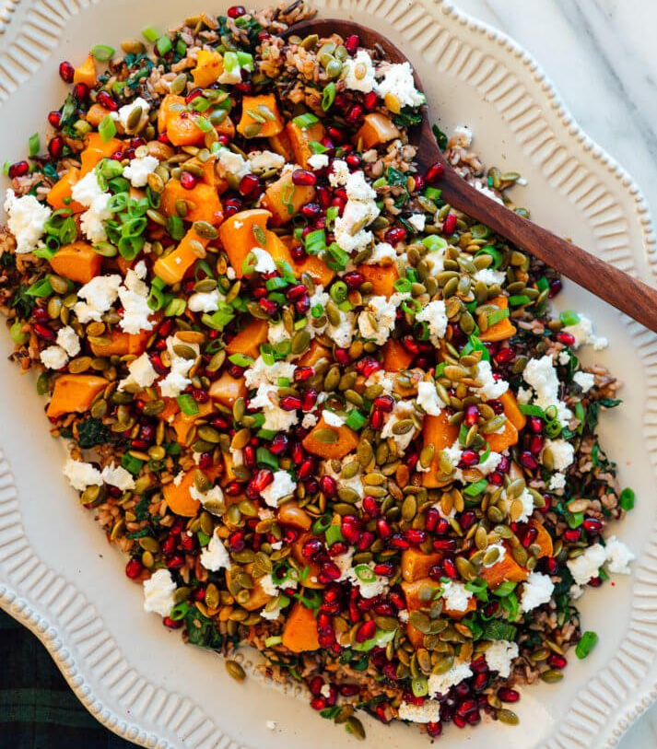
- 2 cups kale, ribs removed and chopped small
- ¾ cup chopped green onion
- 2/3 cup crumbled goat cheese
- Arils from 1 medium pomegranate
- ½ cup raw pepitas
- 2 tablespoons extra-virgin olive oil
- ¼ teaspoon ground cinnamon
- 1 small-to-medium (2 to 2 ½ pounds) butternut squash, cut into ¾-inch cubes
Ginger Dressing
- ¼ cup extra-virgin olive oil
- 2 tablespoons apple cider vinegar
- 1 tablespoon Dijon mustard
- 1 tablespoon maple syrup
- 1 tablespoon grated fresh ginger
- Salt and pepper to taste

DIRECTIONS
- Preheat the oven to 425 degrees Fahrenheit and line a large, rimmed baking sheet with parchment paper or oil.
- Cook the wild rice according to package directions.
- Meanwhile, roast the butternut: Place the cubed butternut squash on your rimmed baking sheet. Drizzle it with the olive oil and sprinkle with desired seasonings. Toss until the cubes are lightly and evenly coated in oil. Arrange them in a single layer and roast for 35 to 50 minutes, tossing after 20 minutes, until they are starting to turn golden on the edges and tender when pierced through with a fork.
- While the wild rice and butternut cook, prepare all of the remaining components. Combine chopped kale and green onion, pomegranate arils, and whisk together all of the dressing ingredients in a small bowl.
- To toast the pepitas, combine pepitas, 1 teaspoon olive oil, ¼ teaspoon each salt and cinnamon in a small skillet. Stir to combine and cook over medium heat for 3 to 5 minutes. Remove the skillet from the heat and set aside.
- Add vegetables, dressing, crumbled goat cheese, pomegranate arils and toasted pepitas to cooked rice and serve.

Vegan Crab Cakes

Yield: 4-8 Servings
Recipe adapted from and photo courtesy of Food Network

Ingredients
- Two 15-ounce cans chickpeas, drained and 1/4 cup liquid reserved
- Pinch cream of tartar
- 2 tablespoons fresh parsley, chopped
- 1 tablespoon lemon juice, plus lemon wedges for serving
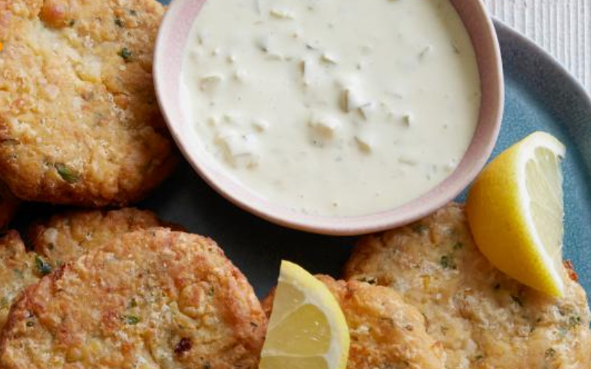
- 2 teaspoons Old Bay Seasoning
- 1 teaspoon honey mustard
- 2 slices of whole-wheat bread/hamburger bun, torn into small pieces
- 2/3 cup white whole-wheat flour
- Vegetable oil
- Kosher Salt
Tartar Sauce:
- 1/4 cup vegan mayonnaise
- 1/2 teaspoon honey mustard
- Pinch Old Bay Seasoning
- 1/2 whole dill pickle, finely chopped
- 1 tablespoon dill pickle brine
DIRECTIONS
1. For the chickpea crab cakes: Place the reserved chickpea liquid into a large bowl, then add the cream of tartar and whip vigorously until foamy and thick.
2. Whisk in the parsley, lemon juice, Old Bay and honey mustard, then add the bread pieces and toss to coat. Let sit until the bread is soft, about 5 minutes.
3. Meanwhile, finely chop the chickpeas (alternatively, you can pinch or smush them). When the bread mixture is ready, add the chickpeas and toss and squeeze the mixture until it holds together. Form into eight 3/4-inch thick patties with rounded edges. Cover and chill for at least 1 hour.
4. For the tartar sauce: Whisk together the mayonnaise, honey mustard, Old Bay, pickle and pickle brine in a small bowl. Refrigerate until ready to serve.
5. Preheat the oven to 350 degrees F. Whisk a pinch of salt into the flour and put on a plate. Pour enough oil to cover the bottom of a large nonstick skillet and heat over medium-high heat. Dredge half of the cakes in the flour.
6. Once the oil is hot and shimmering, add the cakes and cook until crunchy and deep golden brown, about 3 minutes per side. Adjust the heat as necessary to keep them from browning too quickly.
7. Transfer to a baking sheet and repeat with the remaining cakes. Bake until heated completely through, about 5 minutes.
8. Serve the chickpea crab cakes with the tartar sauce and lemon wedges.

Carrot Ginger Soup with Root Vegetables

Makes: 4 Servings
Modified from and photo courtesy of Food Network

INGREDIENTS:
- 3 tablespoons extra-virgin olive oil, plus more for drizzling
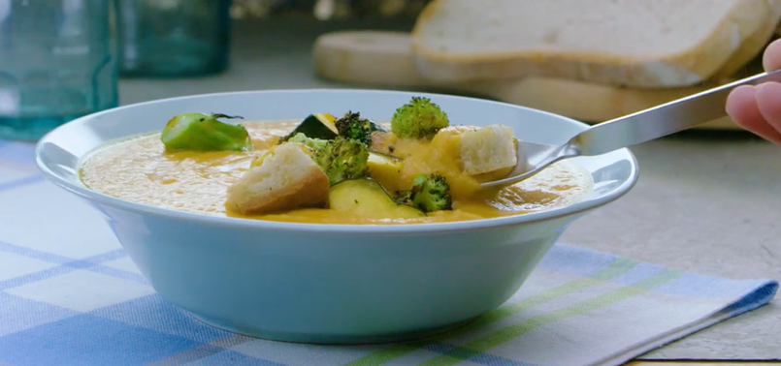
- 2 scallions, sliced
- 2 tablespoons chopped, peeled fresh ginger
- 2 cloves garlic, smashed
- 5 carrots, chopped
- Freshly ground pepper
- 1 14-ounce can coconut milk
- 1 15-ounce can cannellini beans
- 1/2 acorn squash, seeded and chopped into 3/4-inch pieces
- 4 cups roughly chopped broccoli florets and tender stems (about 1 head)
- 2 slices crusty bread (whole grain preferable), cut into 1-inch pieces, plus more bread for serving

DIRECTIONS
- Preheat the oven to 450 degrees F. Heat 1 tablespoon olive oil in a large wide pot or Dutch oven over medium-high heat. Add the scallion whites, ginger and garlic and cook, stirring occasionally, until softened, about 2 minutes. Stir in the carrots and season generously with salt and pepper. Add the coconut milk, beans with their liquid and 3 cups water. Cover and bring to a boil over high heat. Uncover and cook, stirring occasionally, until the carrots are very tender, 18 to 20 minutes.
- Meanwhile, toss the squash, broccoli and bread with the remaining 2 tablespoons olive oil and 1/4 teaspoon each salt and pepper on a rimmed baking sheet. Roast, stirring, until the vegetables are tender and browned and the bread is toasted, about 15 minutes.
- Puree the soup with an immersion blender (or transfer to a regular blender in batches and puree); season with salt and pepper. Divide the soup among bowls. Drizzle with olive oil and top with the vegetable-crouton mixture and scallion greens. Serve with bread.

LOW PREP/DORM RECIPE TIP:
Purchase a low-sodium vegetable soup can/cup. Add protein of choice (diced tofu, rinsed/drained beans, pre-cooked chicken) and additional frozen/canned/fresh vegetables. Heat on the stove top or cover and heat in the microwave.

