Sweet Potato Gnocchi

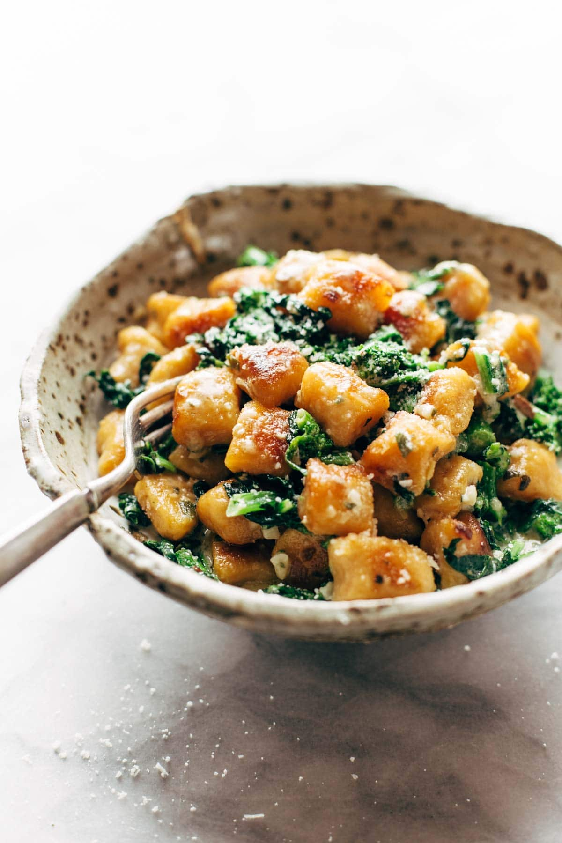
Makes: 6-8 Servings
Modified from PinchOfYum

INGREDIENTS
Gnocchi:
- 1-lb sweet potatoes
- 1 cup ricotta cheese or silken tofu
- ¼ cup parmesan cheese or alternative
- 1 ½ teaspoons salt
- 1 ¼ cup white whole wheat flour (more for dusting)
Sauce and other ingredients:
- 5 cups finely chopped broccoli rabe (stems, leaves and florets)
- 8 Tablespoons margarine or butter
- ⅓ cup milk or alternative
- 2 cloves garlic, minced
- 5-6 sage leaves
- 1 teaspoon sea salt
- ¼ cup parmesan cheese or alternative

DIRECTIONS
- Stick the sweet potato a few times with a fork, wrap in a damp paper towel, and microwave until soft (about 7 minutes)
- Scoop the flesh of the sweet potato into a mixing bowl, discarding the skin. Mix the ricotta, parmesan, and salt until well combined and almost completely smooth. Add the whole wheat flour ½ cup at a time, kneading very gently after each addition.
- Eventually, as the dough becomes easier to handle, transfer it to a clean floured surface and form it into a loaf, about 9x5 inches. Cut a slice off of the loaf on the short side. Roll and stretch the slice on a floured surface until it forms a long, skinny rope-like shape. Cut the rope into 1-inch segments and transfer to a bowl. This is the gnocchi.
- Bring a large pot of water to a boil and add the gnocchi until they rise to the top. Drain and toss gently with a little olive oil to prevent sticking. At this point, the gnocchi can be refrigerated, frozen, or kept out to continue the recipe.
- For the broccoli rabe, bring a large pot of water to boil and prepare a bowl with ice water. Add the broccoli rabe to the boiling water and cook for one minute. Drain and transfer to the ice water to cool and stop the broccoli rabe from cooking further. Drain again and set aside.
- Put it all together. Heat the margarine in a large skillet over medium high heat until lightly bubbling. Add the gnocchi and pan-fry until golden brown on the outside. Add the broccoli rabe, garlic, sage, and salt and pan-fry for a few minutes. Remove from heat and let cool for a few minutes so the margarine thickens just a little. Add the milk to the pan along with the parmesan cheese or alternative. Toss gently a few times to combine and serve immediately with salt, pepper, and a squeeze of lemon juice for taste.

LOW PREP/DORM RECIPE TIPS
If you do not have access to an oven, microwave one medium sized sweet potato on high for 5 minutes. Place the broccoli rabe in a bowl with some water and cover, microwaving for 1 minute in order to steam. Top the mashed sweet potato with the steamed broccoli rabe and top with store-bought marinara sauce or garlic and some margarine.
Another option for this recipe would be to purchase premade sweet potato gnocchi and top with steamed broccoli rabe as described above. Trader Joe’s sells a frozen sweet potato gnocchi with microwave instructions that would be perfect for a dorm room meal.

