Vegan Summer Rolls with Dipping Sauce

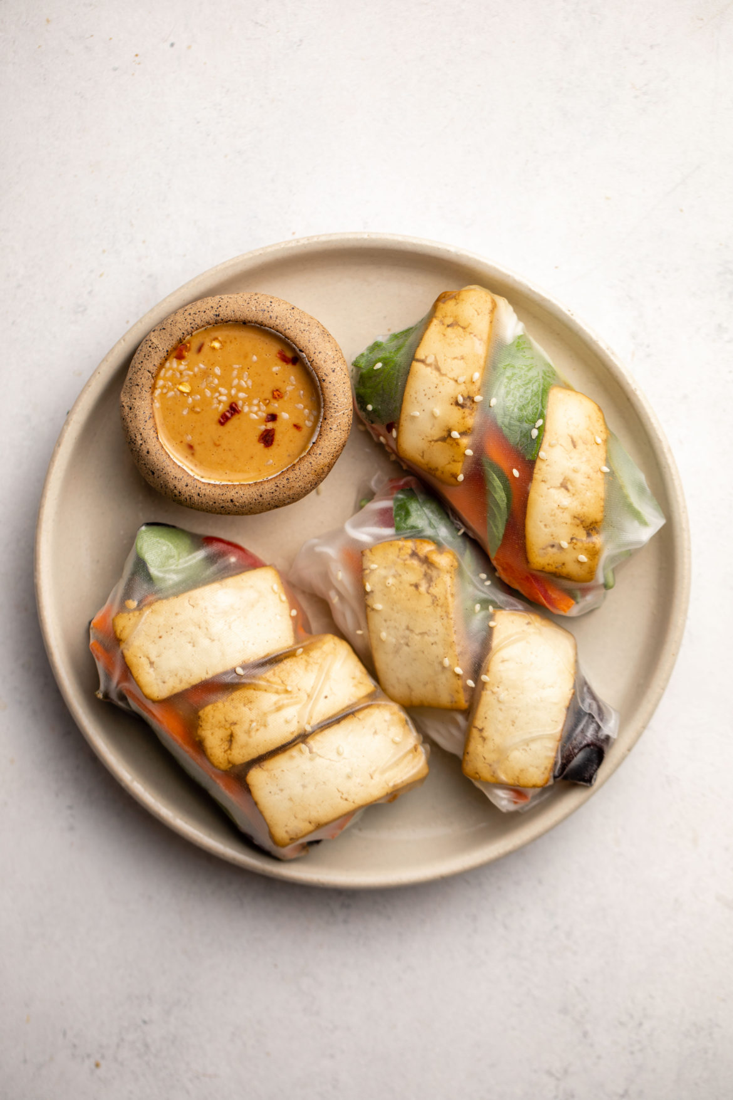
Makes: 10-12 rolls
Modified From FromMyBowl

INGREDIENTS
Rice Paper Rolls:
- 10-12 sheets of rice paper (brown rice paper, if possible)
- Large, wide bowl of warm water
Filling:
- Crunchy veggies (Bell pepper, carrot, and cucumber work well)
- 1 small block of Braised tofu
- 1 cup cooked vermicelli noodles (whole grain, if possible)
- Fresh herbs, such as mint and thai basil
- Salad greens or shredded lettuce
- Optional: Avocado slices

DIRECTIONS
- Prep your ingredients. Cook the vermicelli noodles according to the package directions and thinly slice all of your vegetables and tofu. Arrange all fillings on a large plate or tray for easy access and set by a bowl of warm water and your rice paper.
- Soften the rice paper by soaking it in the bowl of warm water for 5-10 seconds. It works well if the paper is rotated in the bowl in a circular direction, pressing the center of the rice paper into the bowl to completely soak it. Carefully remove the rice paper from the water and place onto a plastic or polished wood cutting board.
- Fill your roll, placing any and all of the fillings that you prepared into the center of the rice paper. It’s best to move quickly here, as the paper becomes very sticky over time.
- Fold each side of the rice paper towards the center, then fold the bottom portion over the filling, towards the top. Use both hands to compress the roll as you roll it towards the top of the rice paper to completely seal it. Move slowly and carefully lift each side of the rice paper so it does not rip.
- Serve and Enjoy! Rolls are best consumed immediately, as they will start to stick together with time. To avoid this, sandwich them between salad greens or veggies so they do not touch each other.

LOW PREP/DORM RECIPE TIP:
When making these rolls in your dorm room, be sure to clear enough space to soak the rice paper and roll them. To reduce the amount of clean-up at the end, use a cutting board as your prep space, and lay paper towels under the shallow bowl of water used to soak the rice paper.

Sweet and Spicy Chili Dipping Sauce
Makes 1 Cup (8 servings)
Adapted from daringgourmet

1/3 cup rice vinegar
1/3 cup water
¼ cup granulated sugar
1 tablespoon rice wine
1-2 teaspoons dried red chili flakes
1 1/2 teaspoons finely minced garlic
1 teaspoon finely minced ginger
1 teaspoon tamari or soy sauce
2 teaspoons cornstarch dissolved in 1 tablespoon water (the sauce will thicken more once cooled)

1.Place all ingredients except for the cornstarch mixture in a small saucepan and bring it to a boil, stirring regularly. If using a microwave, stir in between 20 second intervals.
2.Once the sugar is dissolved stir in the cornstarch mixture, stirring continually until thickened, about 1 minute.
3.Let the sauce cool completely, pour into an airtight jar and store in the refrigerator. Will keep for up to a week.

