Vegetarian Club Picnic Sandwich

Makes: 4 Servings
Modified from LoveAndLemons

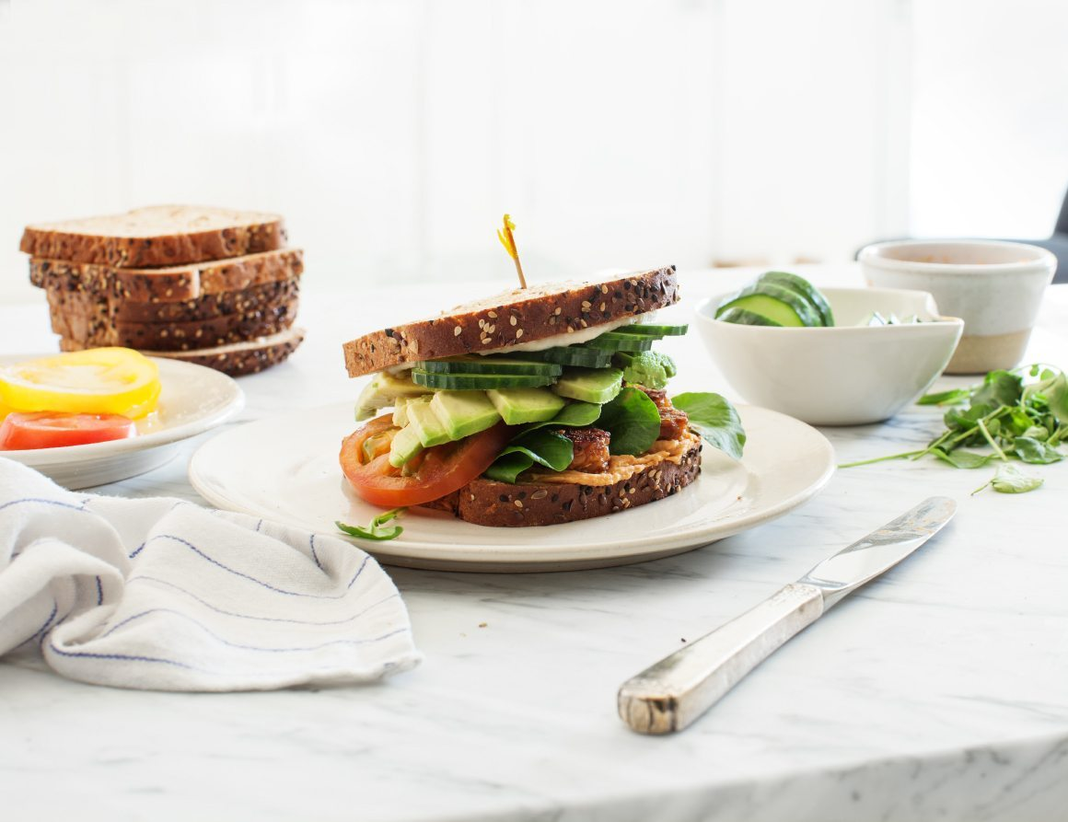
INGREDIENTS
Sandwich:
- 8 Slices whole grain bread, toasted
- Several handfuls of watercress
- 3 tomatoes, thinly sliced
- 1 small cucumber, thinly sliced
- 2 small avocados, thinly sliced
- 8 ounces tofu or tempeh (soaked overnight in a Ziploc bag or Tupperware with ¼ cup rice wine vinegar, 1 tablespoon minced garlic, 1 teaspoon chili flakes, 1 teaspoon salt, and 2 teaspoons sugar)
White Bean Spread & Sun-Dried Tomato Spread:
- 1 15 ounce can white beans, drained and rinsed
- 2 tablespoons extra-virgin olive oil
- Juice of 1 medium lemon
- 2 garlic cloves
- ¼ teaspoon salt
- Freshly ground black pepper
- 3 to 4 sun-dried tomatoes
DIRECTIONS
- Make the sandwich spread in a blender or small food processor. First make the white bean spread by pureeing the white beans, olive oil, lemon juice, garlic, salt, and pepper. Blend until smooth, adding 1 to 2 tablespoons of water if necessary, to blend.
- Scoop out half of the puree and set aside as the White Bean spread.
- Then, add the sundried tomatoes to the blender along with the remaining mixture to create the Sun-Dried Tomato spread. Blend again, adding 1 to 2 tablespoons of water if necessary, to blend.
- Assemble 4 sandwiches with the bread, spread on either side of the sandwich, tempeh, watercress, tomato, cucumber, and avocado.

LOW PREP/DORM RECIPE TIP:
If a small food processor is not available, use a handheld blender to create the spreads for these delicious sandwiches. Another option would be to purchase premade spreads (hummus, pesto, etc).

