Boston University School of Theology Student Association
Executive Board Meeting
February 2nd, 2016
- Welcome/Opening
- Thank You Bailey & Matt for providing the snacks for last week’s Kickoff!
- Sign Up Sheet to help out at Community Lunch
- Tuesday February 16th, 12:30-2PM: Meeting with the Library Staff
- Jordan volunteers to announce Dr. Hickman-Maynard’s Vocation and Voice at Community Lunch tomorrow
- Dean Moore requests more student commitment for lectures for prospective faculty
- Katie Omberg discusses booking of Community Lunch/Ordering Food in general
  - Responsibilities are discussed (Restaurant choice, utensils, delivery, set-up)
  - PDF distributed (facsimile at the bottom of these minutes)
  - Importance of $1050 budget, as well as making sure the restaurant is fine with a purchase order is stressed
  - 11:15-11:30 pickup is needed
  - Sustainability can be kept in mind
  - Catering on the Charles a go to, but not here all-end all
  - Vegetarian options a must
  - Anne notes newer restaurants that can be used that are not on the list below
  - Small Dollar reimbursements not ideal, but done
- Information
  - Excitement for this Semester is high
  - 101 series’ coming up (all possibly in the Basement)
    - Tuesday, February 23rd: Korean 101
    - Monday, March 28th : Disability 101
    - April 4-8th : Immigration 101
    - Mental Health 101 wanted, in the works/ Spiritual Health Interest Group
- What is STHSA helping with this semester?
  - Aforementioned 101 series
  - Vocation and Voice series (Dr. Teddy Hickman-Maynard, Dr. Barbod Salimi, one to be named later)
  - Anti-Racism/White Conversation group
  - Graduation Celebration
  - Diversity and Inclusion Steering Committee
    - Nominations opening TOMORROW
- Next week’s meeting will be in 111B
- Dean’s Fellow Pancake Breakfast (March 16th, 10AM)
- Events from Student Groups?
  - Raices Latinas
    - Raices Latinas Week, March 21-25th , Three events, Tuesday-Thursday
  - Sacred Worth
    - General Meeting, February 4^{th ,} 4PM Anna Howard Shaw Center
  - DSA
    - Cultural Competency
    - Disciplinary Procedures review
    - CV workshop
    - Prospectus Workshop
  - MTS Society
    - Some informal events in the works
  - Possibly Beane House workshop on what to do with a Seminary degree outside of the Church
  - ABS
    - Black History Month events
    - An event starting either this week or next
  - Interfaith Club
    - Events being hammered out
    - Movie event
    - Zen Sword Karate Service
  - Lament Service
    - Create a space of lament
    - Naming of pains
    - TONIGHT
    - Tonight, focusing on voices of an Iowan Muslim community affected by the recent Presidential Campaign and Caucus
  - WSA
    - Contextual Education Workshop
    - ‘Words of Wisdom”
  - International Student Meeting
    - Thursday February 11th
  - Help in Creating a Writing Works evaluation
- Questions/Concerns?
  - Connecting with the BTI?
    - Potential social with BC?/BTI Mixer
    - Interrogating the Rhetoric of Healing Conference (April 9th)
  - New Events Promotion
    - Website form to apply for events
    - Link of the BU Calendar
    - Building up a lot of our photos
      - Events of where to take photos
      - Interest in the photoshoot, contact Alisa Harris
      - Classes also a point of interest to be photographed
- Closing/Meeting Adjourned

Attendance
Lauren DeLano (STHSA)
James Dooley (STHSA)
Matt Llewelyn (STHSA)
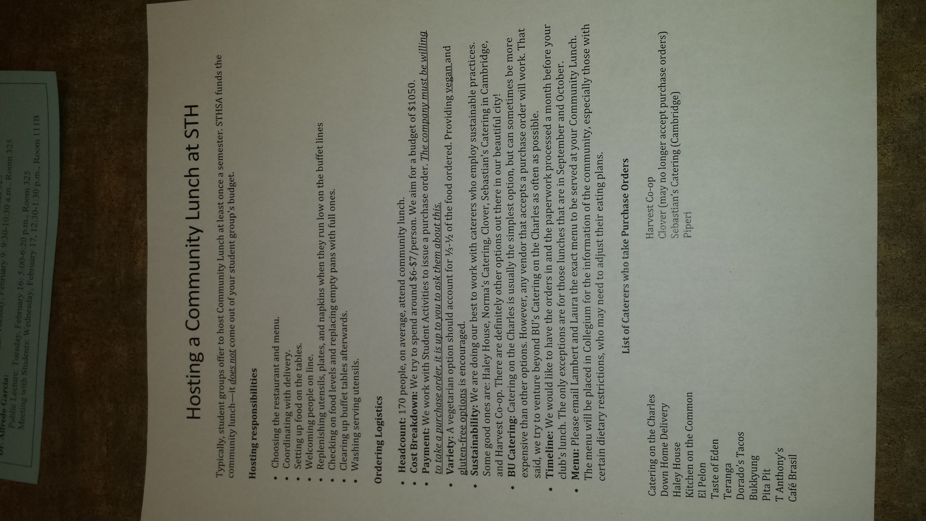
Alyssa Baker (WSA)
Bailey Brawner (STHSA)
Chad Moore (MTS Society)
Anne Hillman (DSA)
Alisa Harris
Lise Mitner (Interfaith Club)
Cesar Linares (Raices Latinas)
Katie Omberg (Sacred Worth)
Jordan Zepher (ABS)

